

**Intelligent Decision Support System**

**Conceptual Interpretation of clusters**

**Reference example of two criteria**

**BL&partial-CWA**

**BL+G&CWA**

Karina Gibert Oliveras

Master in Artificial Intelligence

2011-10-26

**Cutting Dendrogram of “postdifeintegrado” Data ………………………….…………………….……3**

**Description of BL&partial-CWA…………………………………………………………………………..………4**

**Validation of BL&partial-CWA…………………………………………………………………………………….5**

**First Iteration…………………………………………………………………………………………………..6**

**Second Iteration…………………………………………………………………………………………….11**

**Third Iteration…………………………………………………………………………………………….….16**

**Forth Iteration……………………………………………………………………………………………….21**

**Fifth Iteration…………………………………………………………………………………………….…..26**

**Final Solution for BL&partial-CWA………………………………………………………………….31**

**Description of BL+G&CWA………………………………………………………………………………………..34**

**Validation of BL+G&CWA………………………………………………………………………………………….36**

**First Iteration…………………………………………………………………………………………………36**

**Second Iteration…………………………………………………………………………………………….37**

**Third Iteration……………………………………………………………………………………………….38**

**Forth Iteration……………………………………………………………………………………………….39**

**Fifth Iteration…………………………………………………………………………………………………40**

**Final Solution for BL+G&CWA…………………………………………………………………………41**

**Annex I: BC0……………………………………………………………………………………………………………..44**

**Annex II: BC1…………………………………………………………………………………………………………….51**

**Annex III: BC2……………………………………………………………………………………………………………57**

**Annex IV: BC3…………………………………………………………………………………………………………..62**

**Annex V: BC4……………………………………………………………………………………………………………68**

1. **Get the clustering**

Open KLASS

Open the dataset “postdifeintegrado.*”

Perform a “classificació condicionada” using “Alberto3” as conditional variable

Ward’s criterion

Gibert’s mixed metrics with alpha and beta automatics

Visualize the dendrogramm (it will correspond to figure 1)

The correct cut is in 6 classes.

The conceptualization starts from the root of the tree and evolves hierarchically finding at every iteration the variables that behave different in a pair of clusters, inheriting properties from the ancestor classes.

KLASS implements several criteria. Here two of them are illustrated

1. **Cutting Dendrogram of “postdifeintegrado” Data**

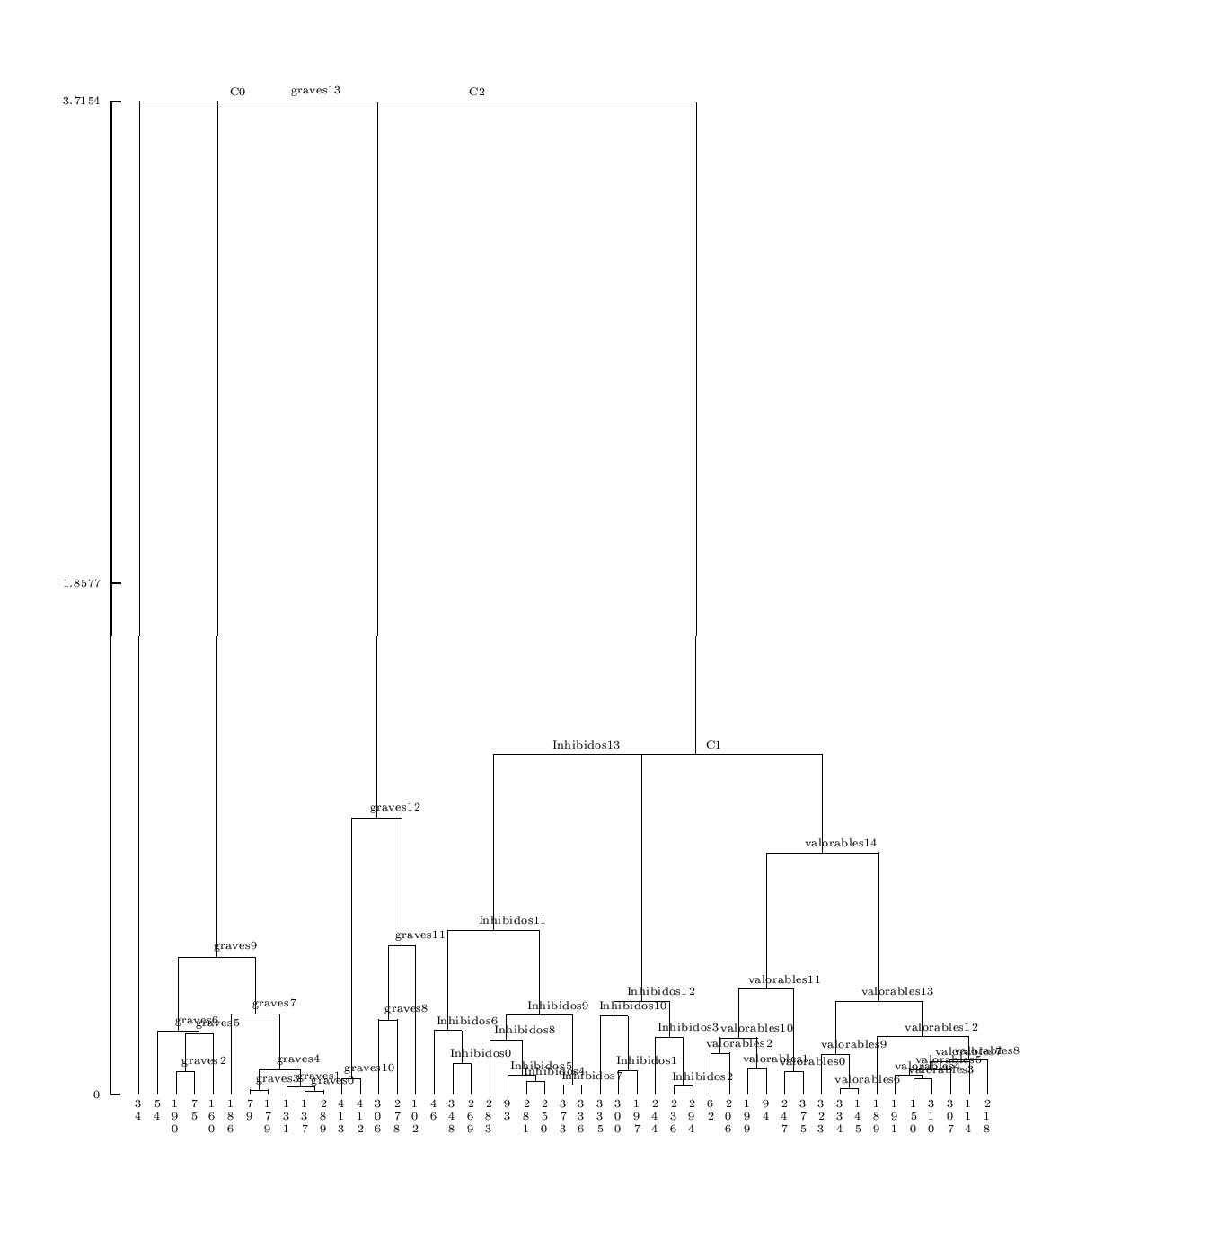 Figure-1

1. **Description of BL&partial-CWA**

For each of the 2 classes:

Find all the rules with "Confiança = 1" and maximum "Cobertura relativa"

a) If a single rule for each class is found, being Ai and Aj their antecedents,

* if they refer to the same variable, store both as the rules for each class (10.21 and 10.22)

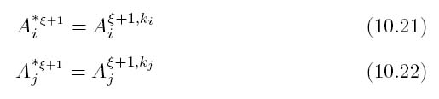

* else, the Close World Assumption will be introduced by using for every class a second term with the negation of the description of the other class "Ai or NOT(Aj)" (10.23 and 10.24)

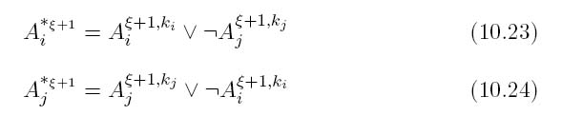

b) If there are many rules

* Chain the antecedents of all rules with "Confiança = 1" and "Cobertura relativa = 1" as indicated in (10.25) and (10.26)

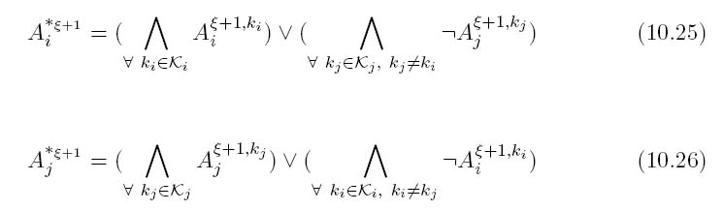

* else chain the antecedents as indicated in (10.27) and (10.28)

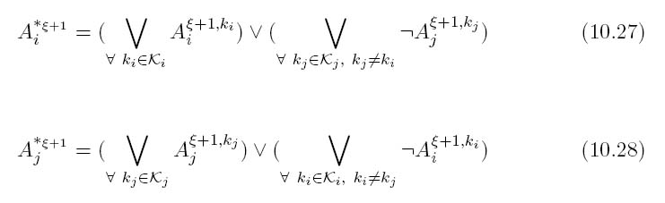

1. **Validation of BL&partial-CWA**

A step by step development of the application of the BL&partial-CWA to a real case study is presented. The 6 classes classification is to be interpreted. This means to run 5 iterations of the CCEC method.

**3.1.First Iteration:**

The 2-classes cut of the dendogram produces the classes {c0 , c1} . Figure 2 shows the number of elements per class

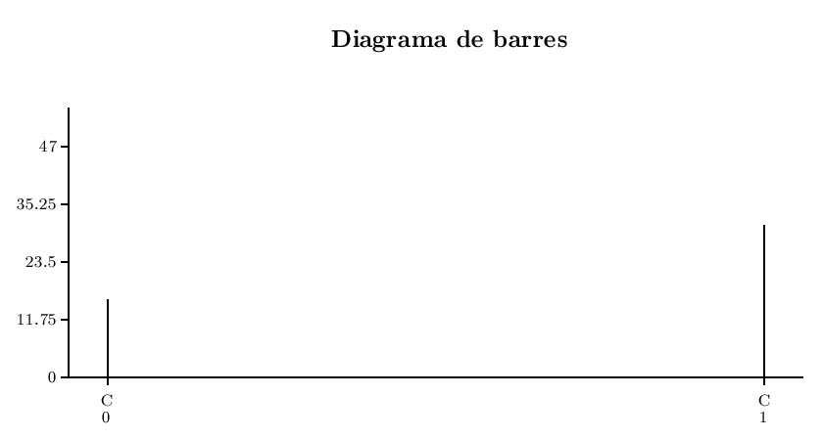

Figure-2

Figure-3 is the table of frequencies of the 2-classes cut.

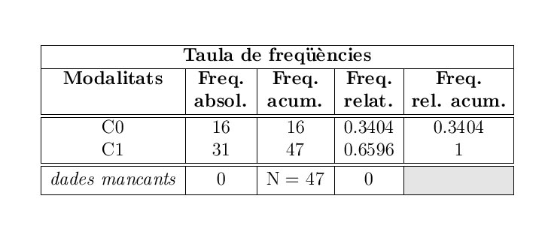

Figure-3

Result can be visually followed in the clustering diagram which is shown above (Figure-1).

The 2-classes cut defines a qualitative variable with the class of every object (C0 or C1), named P2. The boxplot-based induction rules is applied to every variable in the data matrix versus P2 and a first knowledge base BC0 is obtained and listed in ‘Annex I’. Table-1 shows the quality of the rules:

**In First Iteration Initial class is split in two classes -> [C0 , C1]**

**BC0:**

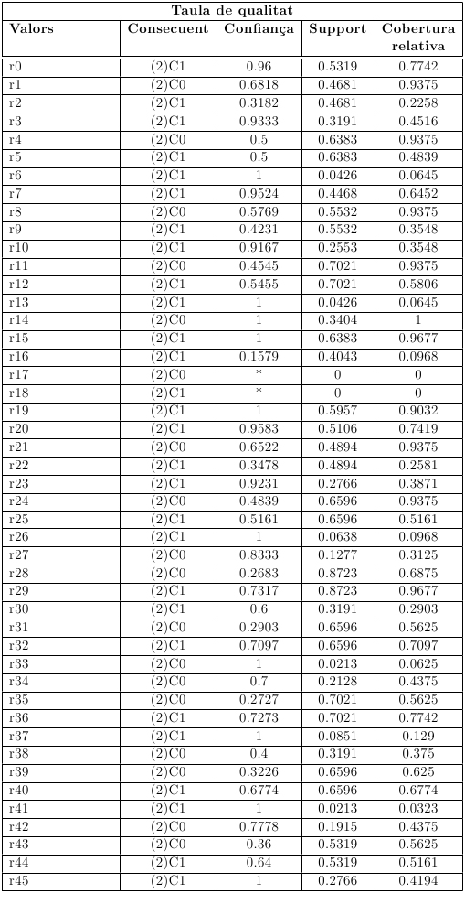

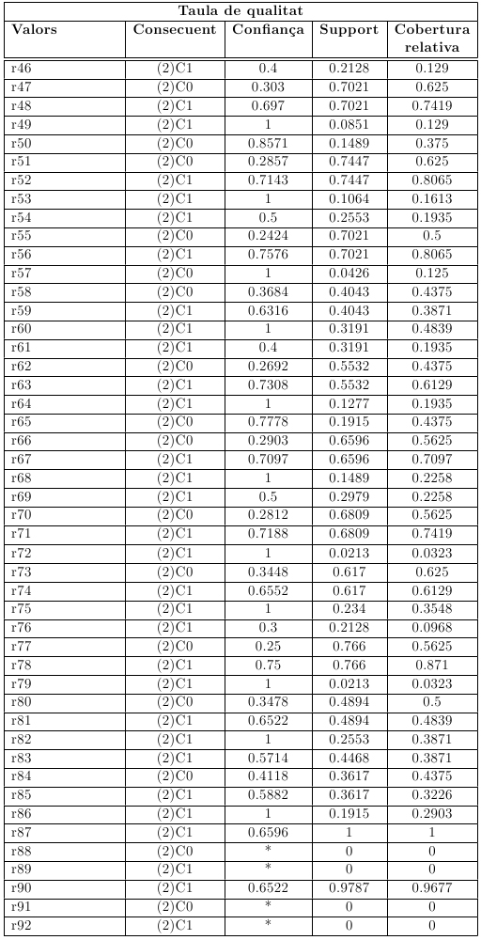

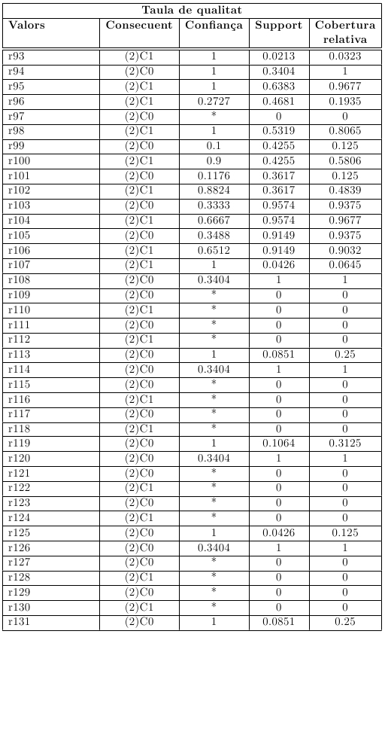

Table-1

BL & Partial CWA criterion says to select rules with ‘Max Confianca’ and ‘Max Cobertura Relativa’ in table-1 for every class

For **C0**: (Max Confianca = 1) and (Max Cobertura Relativa = 1)

* r14 >> ((Stroop.p.c.post => 0) ᴧ (Stroop.p.c.post <= 0))
* r94 >> ((Stroop.int.post => -25) ᴧ (Stroop.int.post <= -25))

For **C1**: (Max Confianca = 1) and (Max Cobertura relative = 0.9677)

* r15 >> ((Stroop.p.c.post > 14) ᴧ (Stroopp.p.c.post < 60))
* r95 >> ((Stroop.int.post => -18.89) ᴧ (Stroop.int.post <= 17.1))

Descriptors of classes C0 and C1 are the following.

**BL & Partial CWA:**

* AC02 ->> (((Stroop.p.c.post => 0) ᴧ (Stroop.p.c.post <= 0)) ᴧ ((Stroop.int.post => -25) ᴧ (Stroop.int.post <= -25)))
* AC12 ->> (((Stroop.p.c.post > 14) ᴧ (Stroopp.p.c.post < 60)) ᴠ ((Stroop.int.post => -18.89) ᴧ (Stroop.int.post <= 17.1)))

Close world assumption do not apply in this iteration because the descriptor variables are the same for both classes

**3.2. Second Iteration: class ‘C0’ from the previous iteration is split in two classes -> [graves13 , 34]**

**BC1:**

In this iteration the differences between graves13 and 34 are found. Only the elements of C0 are considered. A selection of a subset of the data matrix is performed by indicating “elements with P2=C0”

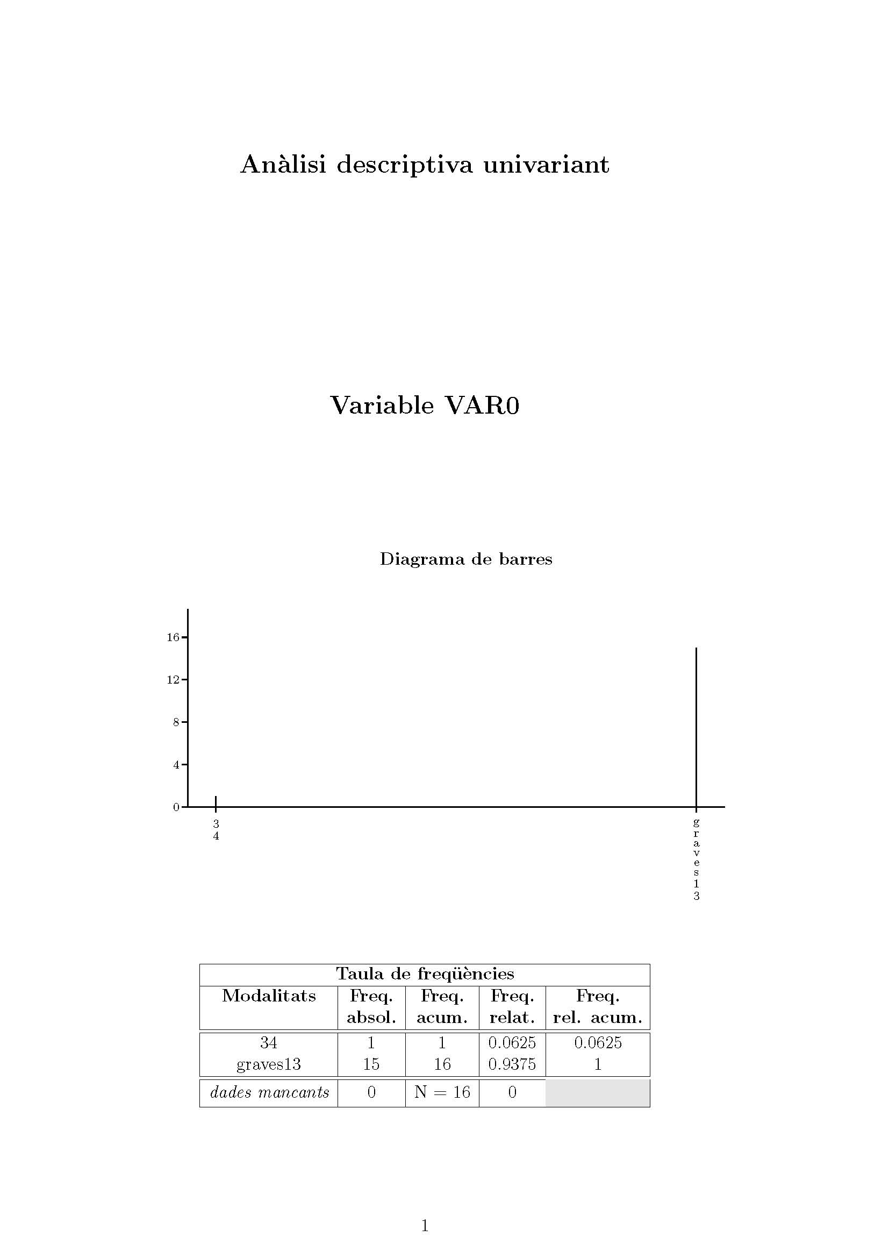

Figure-4

Figure-4 describes the composition of the classes {34, graves13}. The boxplot-based induction rules is applied for every variable in the data matrix versus the partition P2-3={34, graves13} and the knowledge base BC1 is obtained and listed in ‘Annex II’. Table-2 shows the quality of the rules:

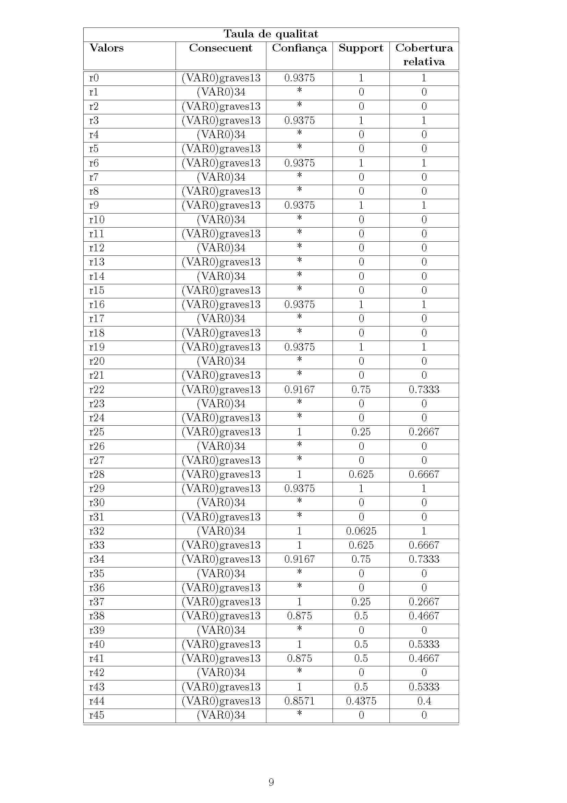

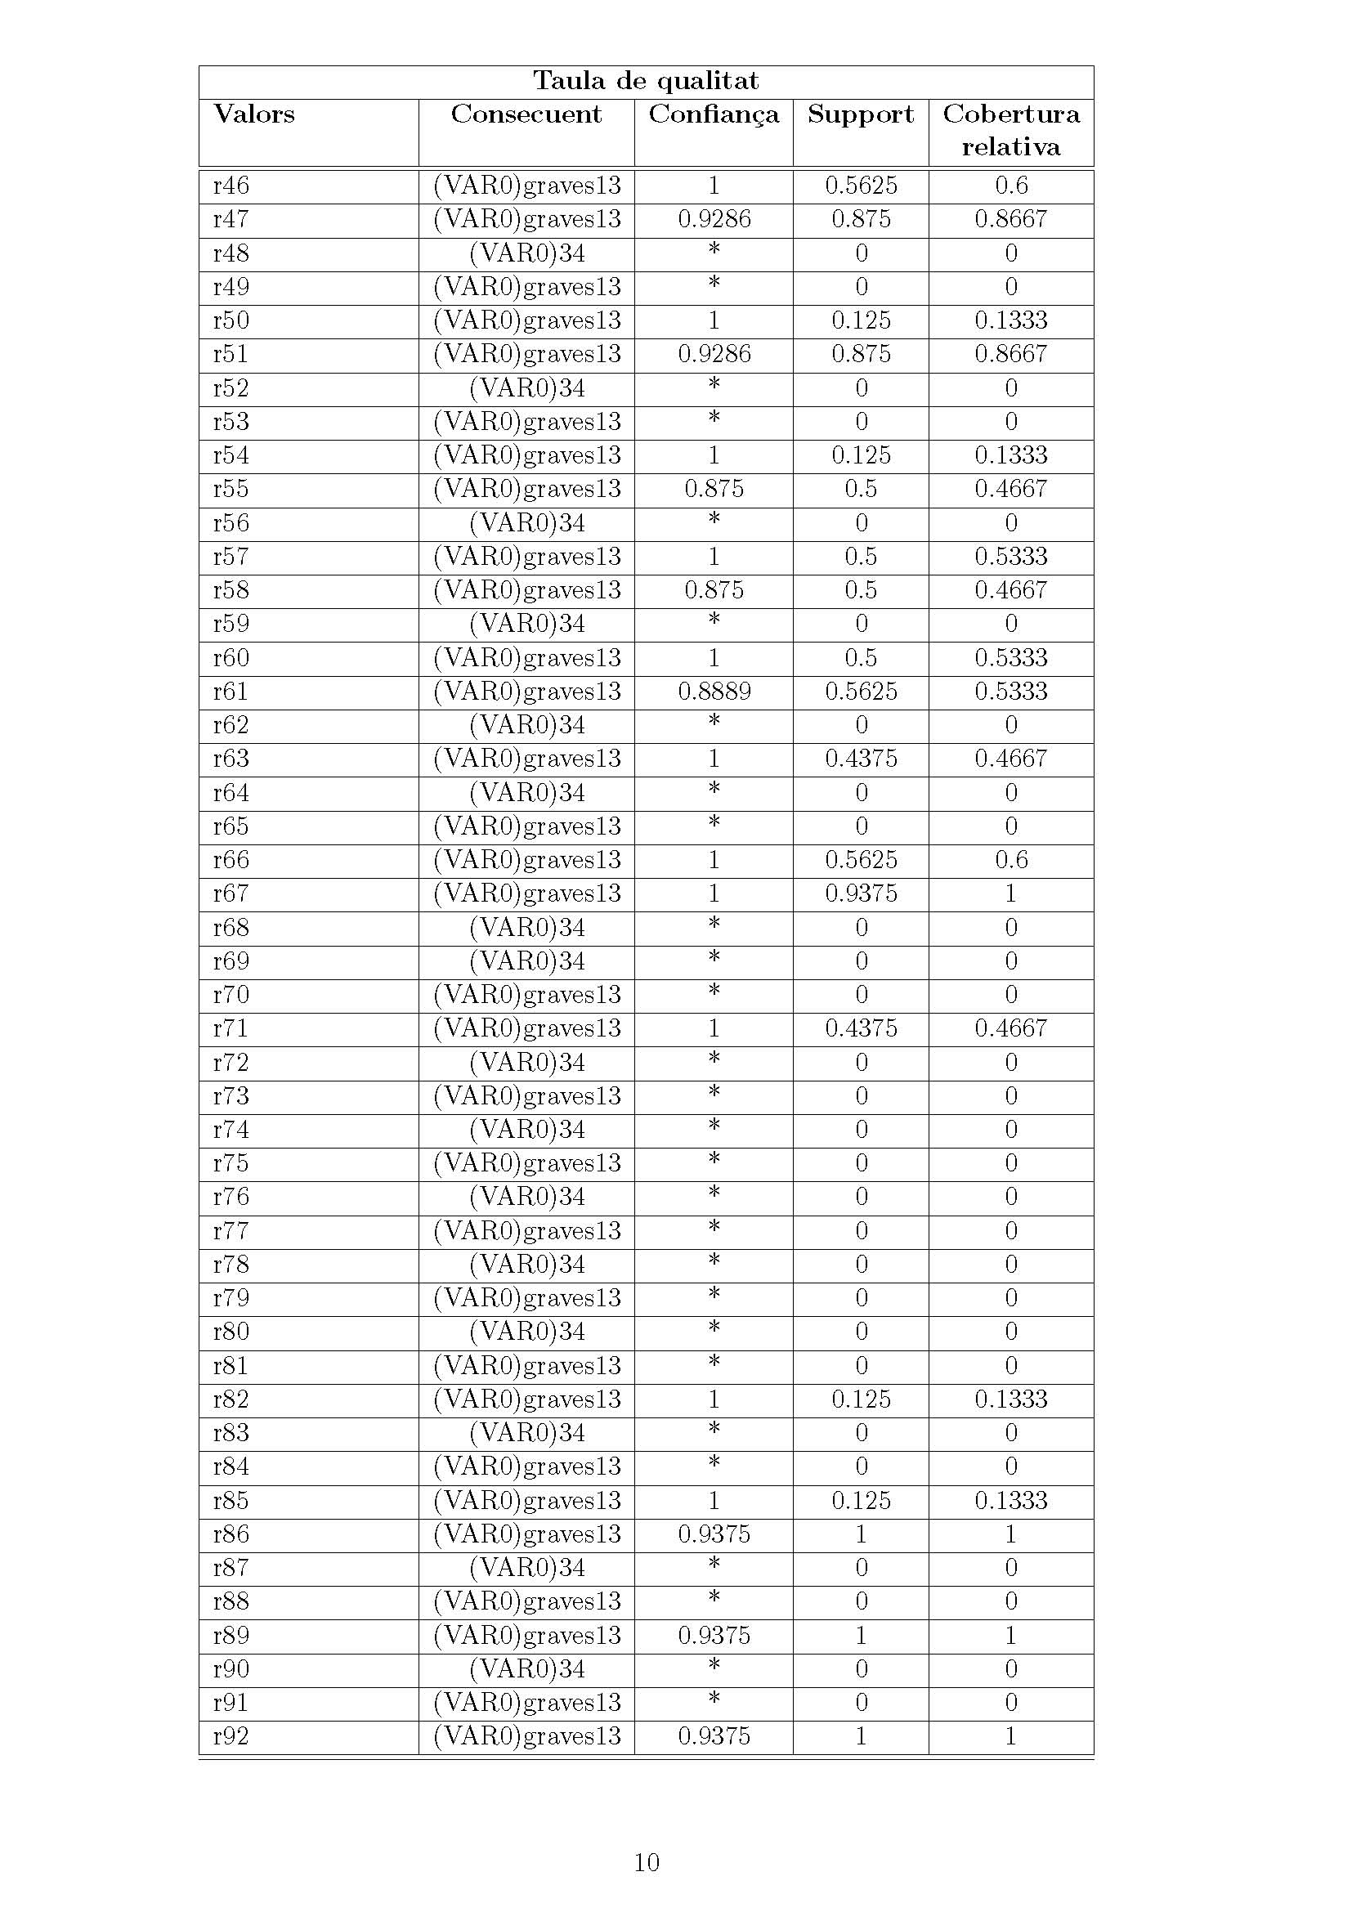

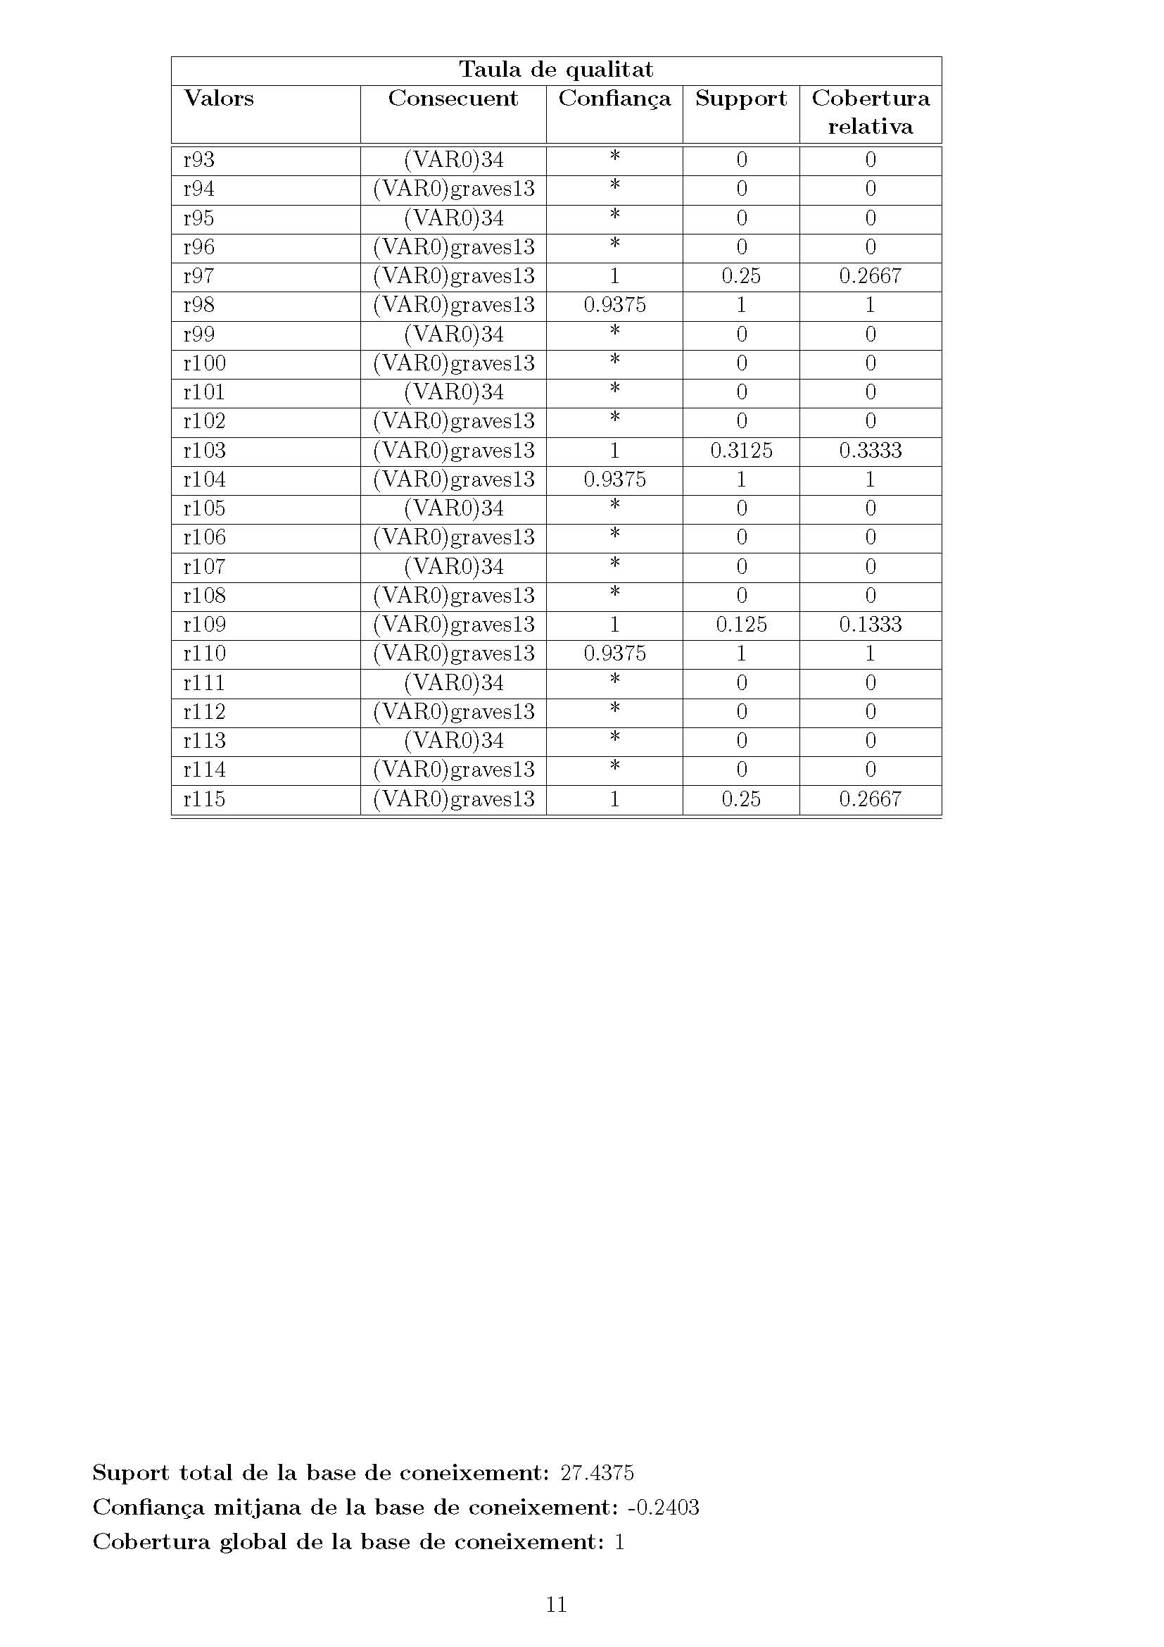

Table-2

The rules for ‘Max Confianca’ and ‘Max Cobertura Relativa’ in table-2 are the following:

For **graves13**: (Max Confianca = 1) and (Max Cobertura Relativa = 1)

* r67 >> ((B.v.rev.post => 0) ᴧ (B.v.rev.post <= 7))

For **34**: (Max Confianca = 1) and (Max Cobertura relative = 1)

* r32 >> ((B.d.i.dife => -1) ᴧ (B.d.i.dife <= -1))

**The method BL & Partial CWA provides the following concepts for classes in P2-3:**

* Graves 13:

r67 ᴠ¬ r32 (10.23)

((B.v.rev.post => 0) ᴧ (B.v.rev.post <= 7))ᴠ¬ ((B.d.i.dife => -1) ᴧ (B.d.i.dife <= -1))

* 34:

r32 ᴠ¬ r67 (10.24)

((B.d.i.dife => -1) ᴧ (B.d.i.dife <= -1)) ᴠ¬ ((B.v.rev.post => 0) ᴧ (B.v.rev.post <= 7))

**3.3. Third Iteration: class ‘graves13’ from the previous iteration is split in two classes -> [graves12 , graves9]**

**BC2:**

In this iteration a submatrix containing only the elements of class graves13 is used

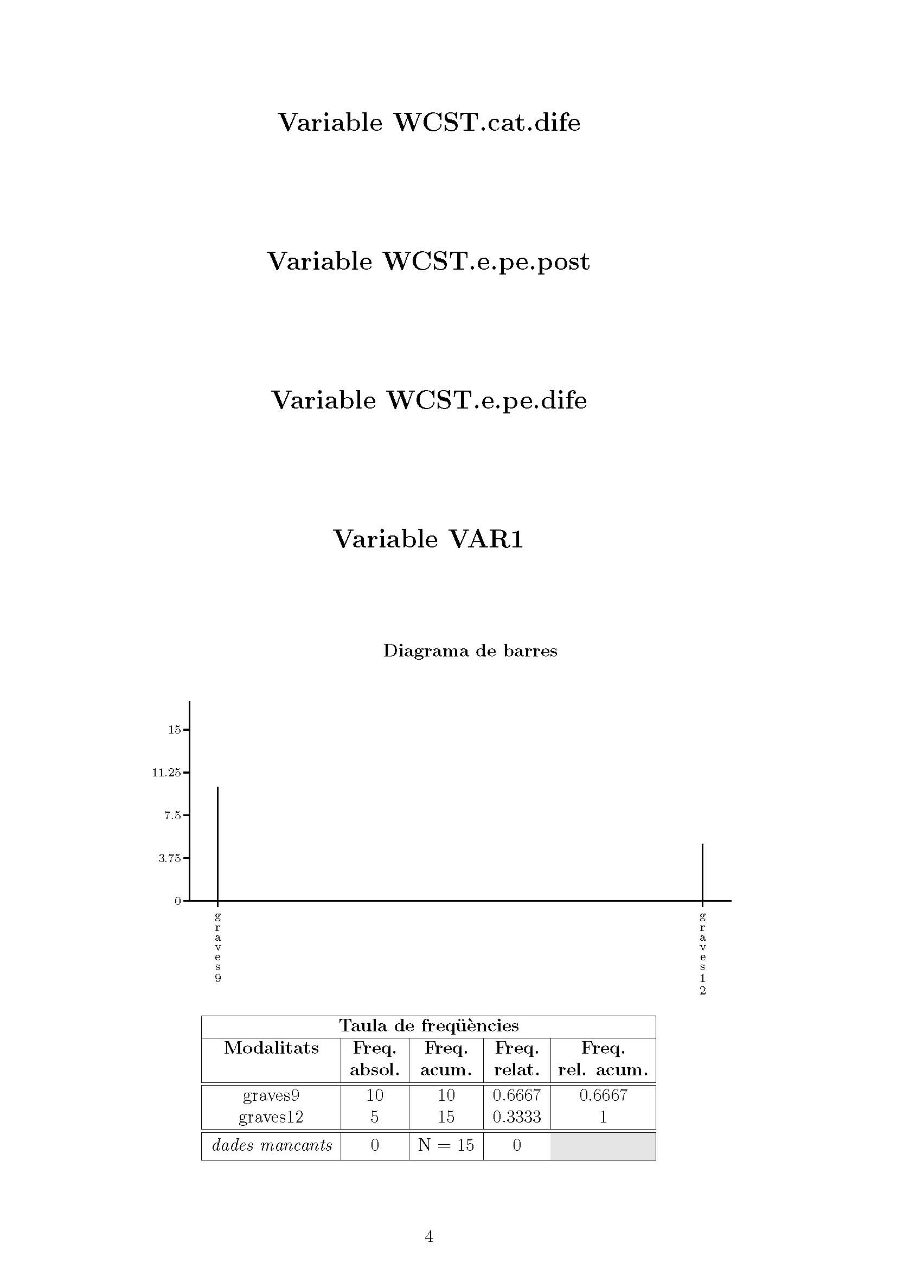

Figure-5

Figure-5 describes the composition of the classes P2-4={graves9, graves12}. The boxplot-based induction rules is applied for every variable versus the partition P2-4 and the resulting knowledge base is BC2 and it is listed in ‘Annex III’. Table-3 shows the quality of the rules:

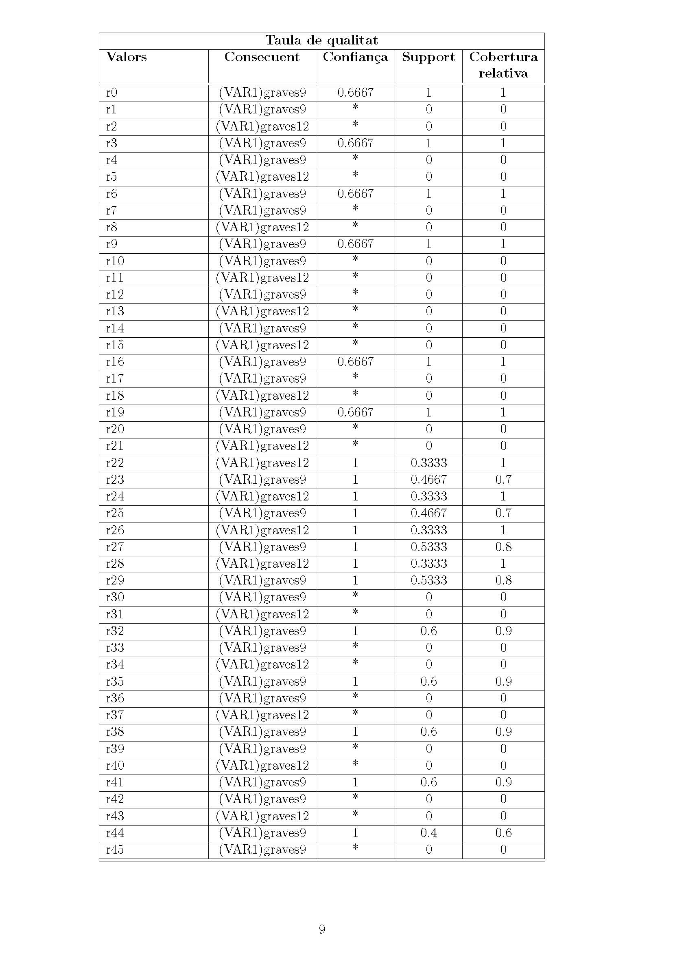

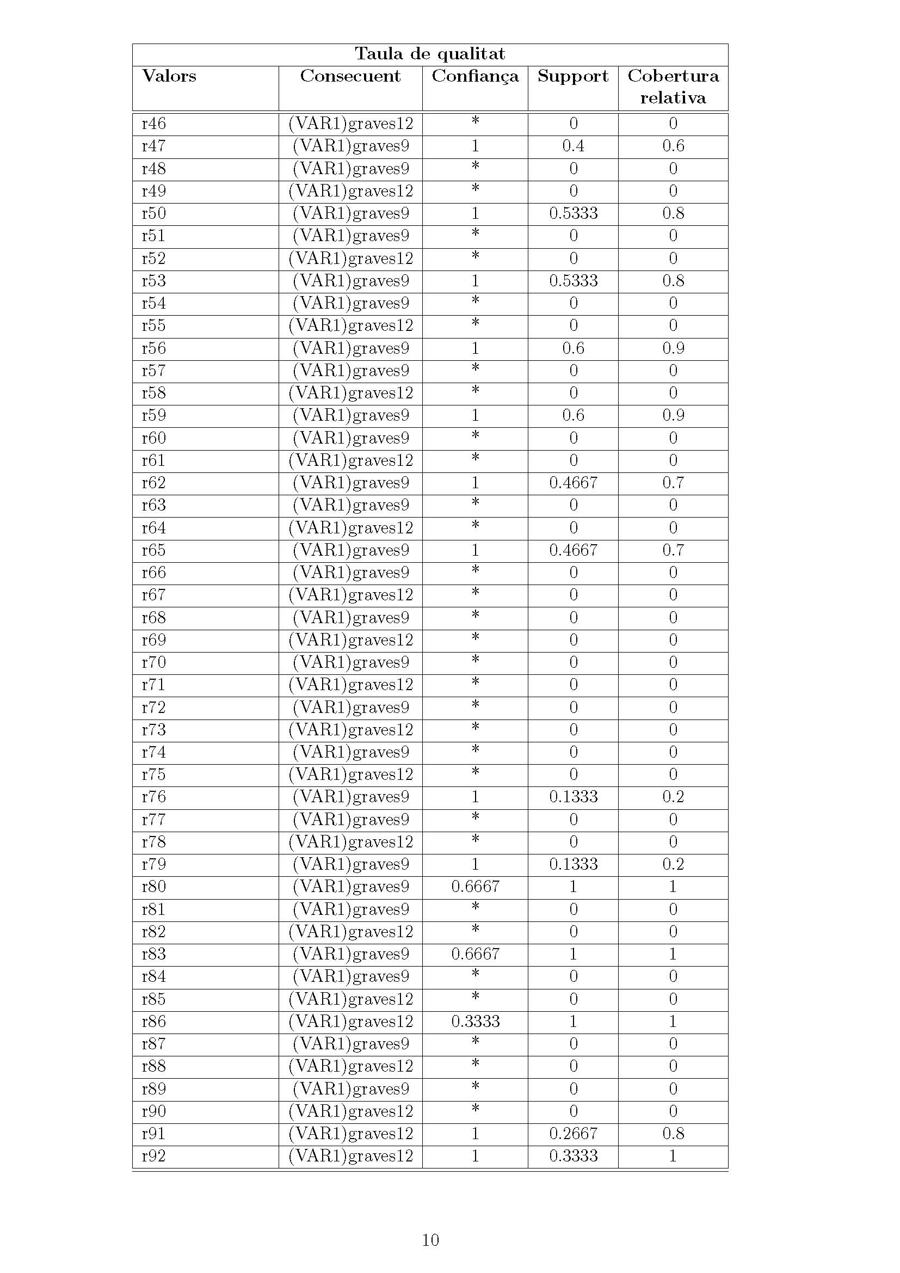

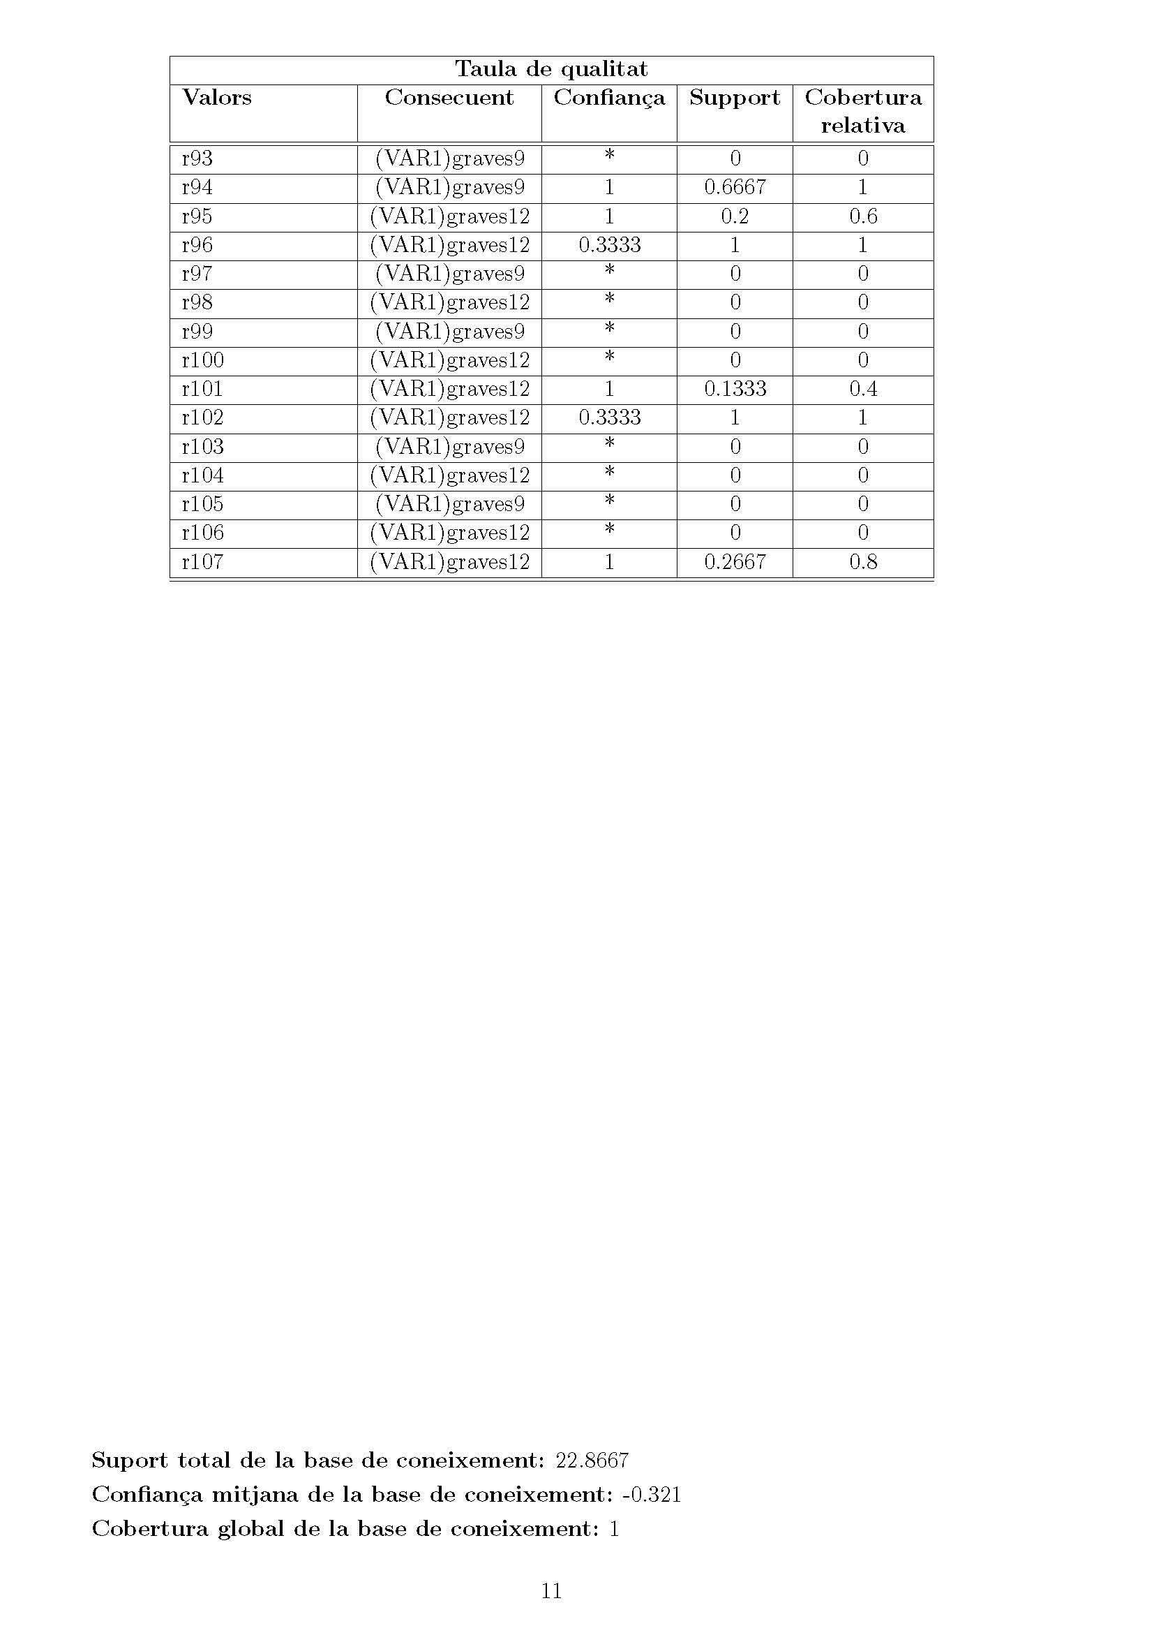

Table-3

The rules with ‘Max Confianca’ and ‘Max Cobertura Relativa’ in table-3 are listed bellow.

For **graves12**: (Max Confianca = 1) and (Max Cobertura Relativa = 1)

* r22 >> ((B.d.d.post => 0) ᴧ (B.d.d.post <= 0))
* r24 >> ((B.d.d.dife => 0) ᴧ (B.d.d.dife <= 0))
* r26 >> ((B.d.i.post => 0) ᴧ (B.d.i.post <= 0))
* r28 >> ((B.d.d.dife => 0) ᴧ (B.d.d.dife <= 0))
* r92 >>((den.vv.post => 2) ᴧ (den.vv.post <= 10))

For **graves9**: (Max Confianca = 1) and (Max Cobertura relative = 1)

* r94 >> ((den.vv.post => 0) ᴧ (den.vv.post <= 0))

**The BL & Partial CWA provides the following concepts:**

* graves12:

(r22 ᴧ r24 ᴧ r26 ᴧ r28 ᴧ r92) (10.25)

(((B.d.d.post => 0) ᴧ (B.d.d.post <= 0)) ᴧ ((B.d.i.dife => 0) ᴧ (B.d.i.dife <= 0)) ᴧ ((B.d.i.post => 0) ᴧ (B.d.i.post <= 0)) ᴧ ((B.d.d.dife => 0) ᴧ (B.d.d.dife <= 0)) ᴧ ((den.vv.post => 2) ᴧ (den.vv.post <= 10)))

* graves9:

(r94) ᴠ ¬ (r22 ᴧ r24 ᴧ r26 ᴧ r28) (10.26)

((den.vv.post => 0) ᴧ (den.vv.post <= 0)) ᴠ ¬ (((B.d.d.post => 0) ᴧ (B.d.d.post <= 0)) ᴧ ((B.d.i.dife => 0) ᴧ (B.d.i.dife <= 0)) ᴧ ((B.d.i.post => 0) ᴧ (B.d.i.post <= 0)) ᴧ ((B.d.d.dife => 0) ᴧ (B.d.d.dife <= 0)))

**3.4. Forth Iteration: ‘C1’ split in two classes -> [inhibidos13 , valorables14]**

**BC3:**

In this case, the elements of C1 are used

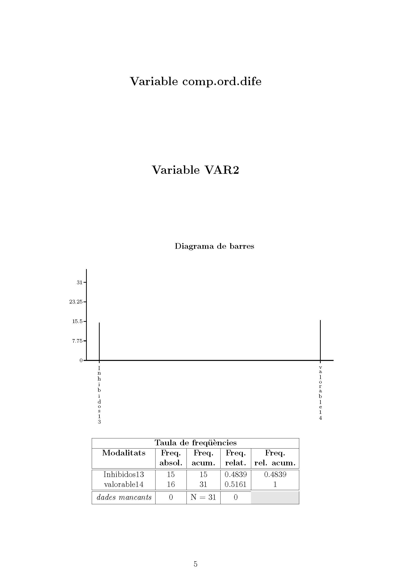

Figure-6

Figure-6 shows the composition of P2-5={inhibidos13, valorable14}. The boxplot-based indution rules is applied for every variable in P2-5 and the knowledge base BC3 is listed in ‘Annex IV’. Table-4 shows the quality of the rules:

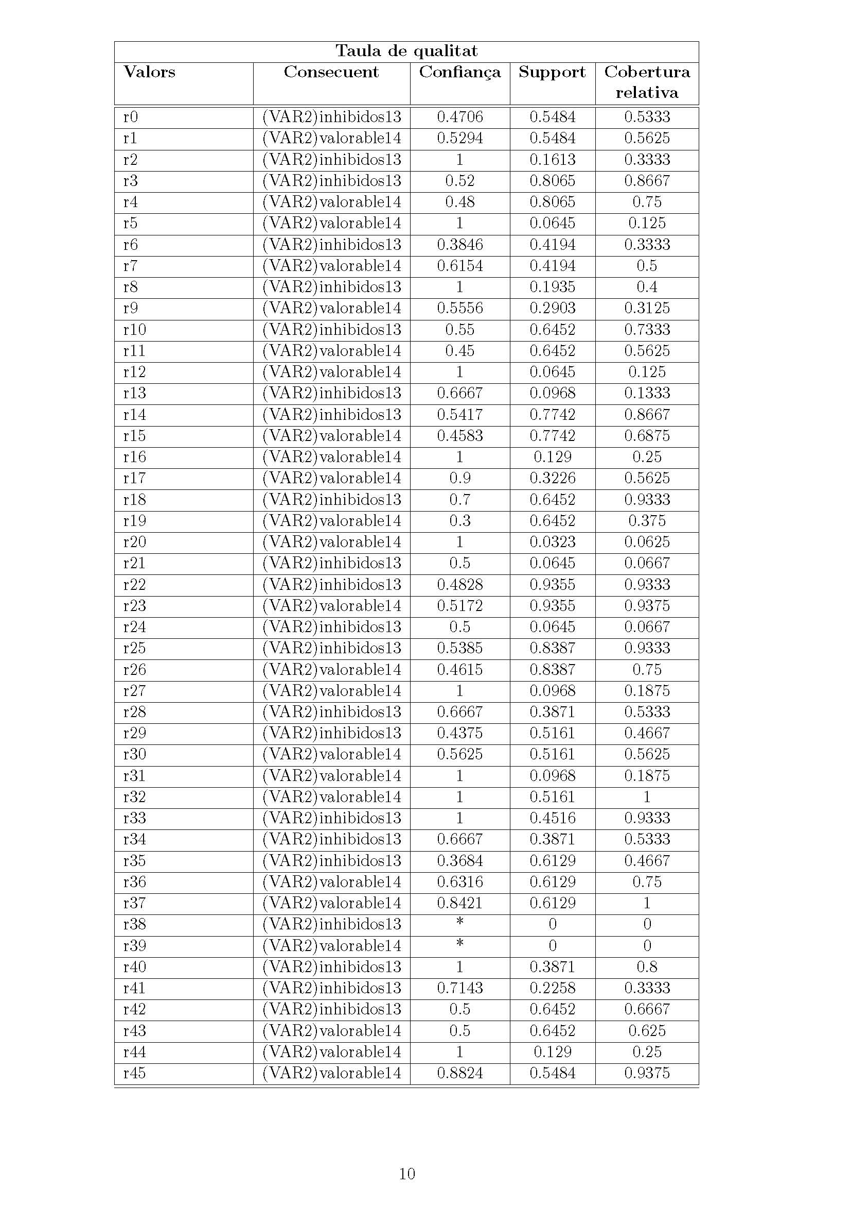

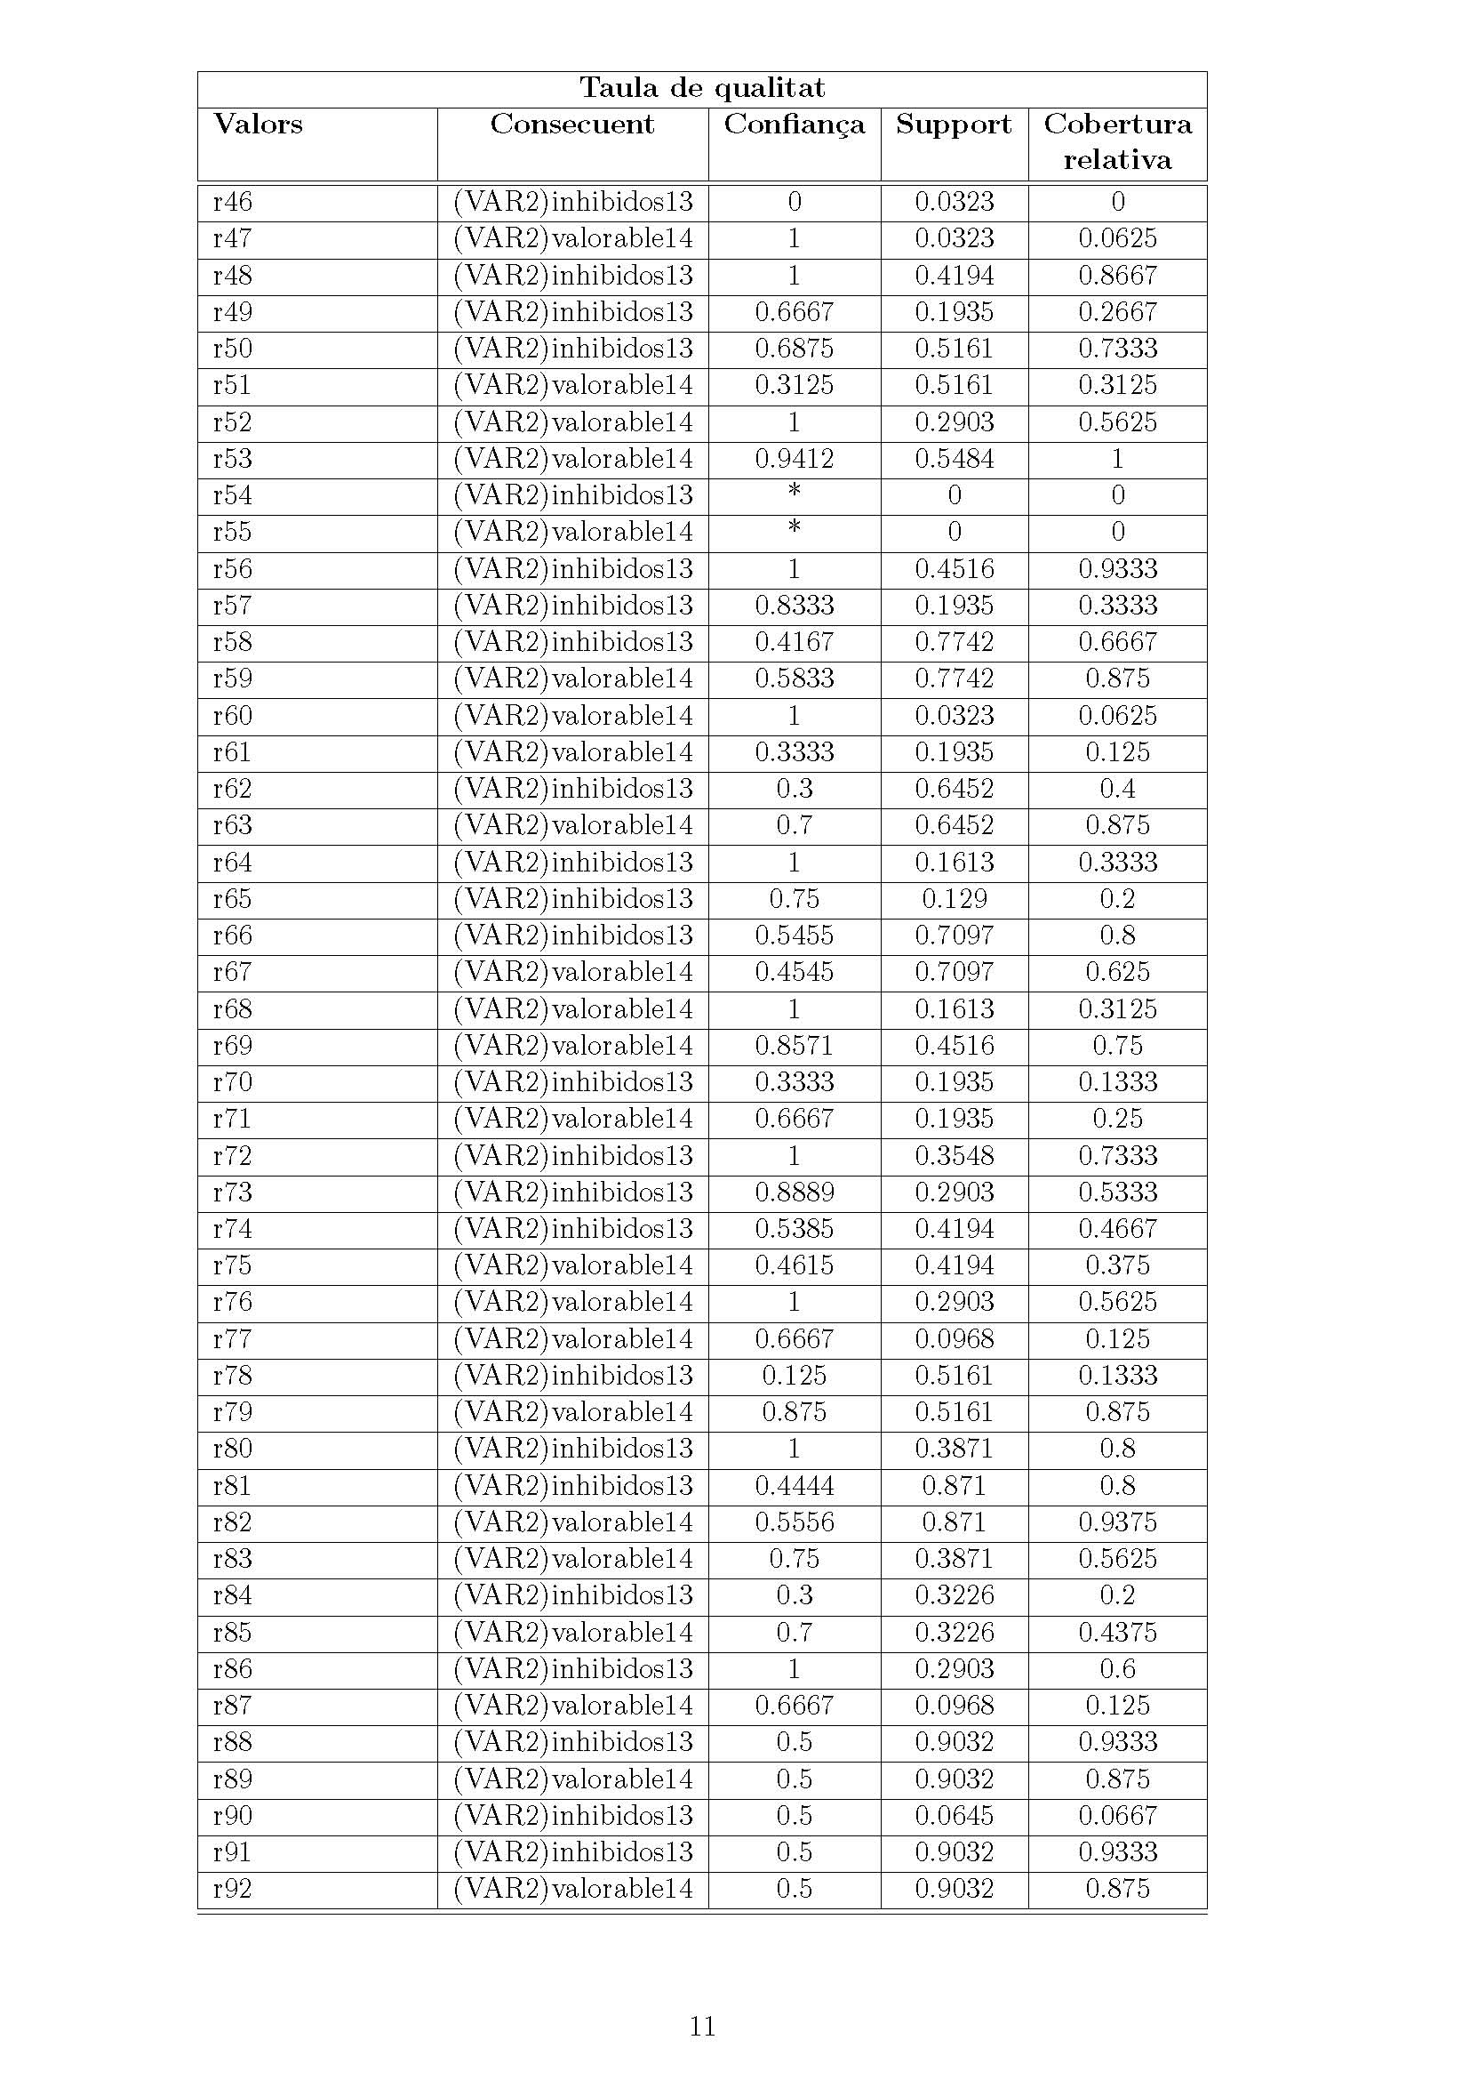

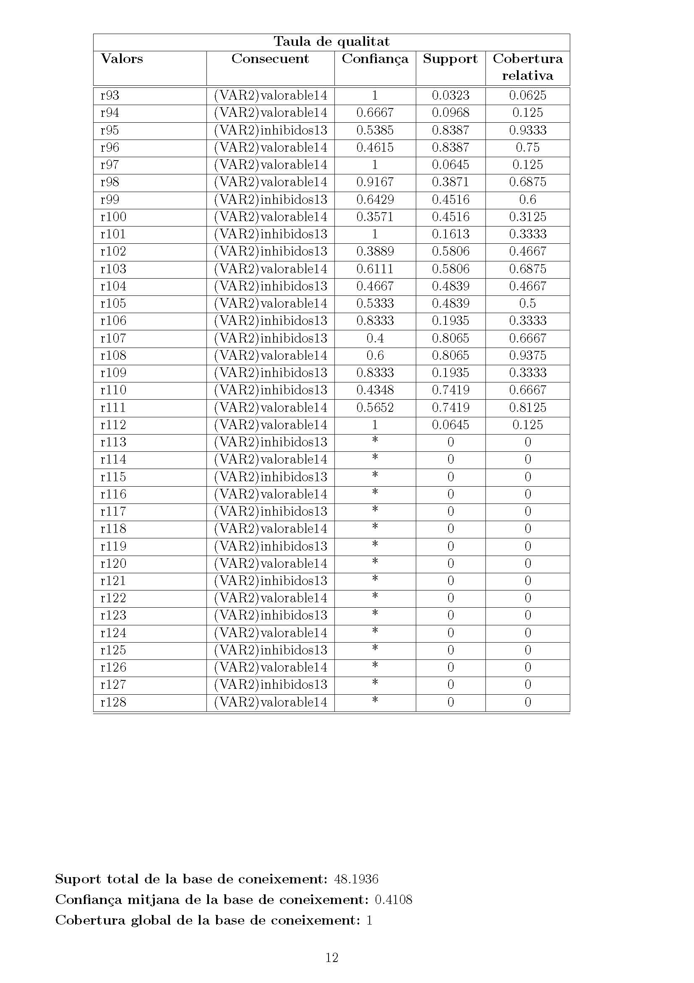

Table-4

The rules with ‘Max Confianca’ and ‘Max Cobertura Relativa’ in table-4.

For **valorables14**: (Max Confianca = 1) and (Max Cobertura Relativa = 1)

* r32 >> ((B.d.d.dife => -1) ᴧ (B.d.d.dife <= 2))

For **inhibidos13**: (Max Confianca = 1) and (Max Cobertura relative = 0.9333)

* r33 >> ((B.d.d.dife > 3) ᴧ (B.d.d.dife <= 7))
* r56 >> ((B.m.c.p.p.dife > 5) ᴧ (B.m.c.p.p.dife <=16))

**The criterion BL & Partial CWA provides the following concepts:**

* valorable14:

(r32) ᴠ ¬ (r56) (10.25)

((B.d.d.dife => -1) ᴧ (B.d.d.dife <= 2)) ᴠ¬ ((B.m.c.p.p.dife > 5) ᴧ (B.m.c.p.p.dife <=16))

* inhibidos13:

(r33 ᴠ r56) (10.28)

((B.d.d.dife > 3) ᴧ (B.d.d.dife <= 7)) ᴠ ((B.m.c.p.p.dife > 5) ᴧ (B.m.c.p.p.dife <=16))

**3.5. Fifth Iteration: Selected class ‘inhibidos13’ from the previous iteration is split in two classes -> [inhibidos11 , inhibidos12]**

**BC4:**

In this iteration only elements of inhibidos13 are used

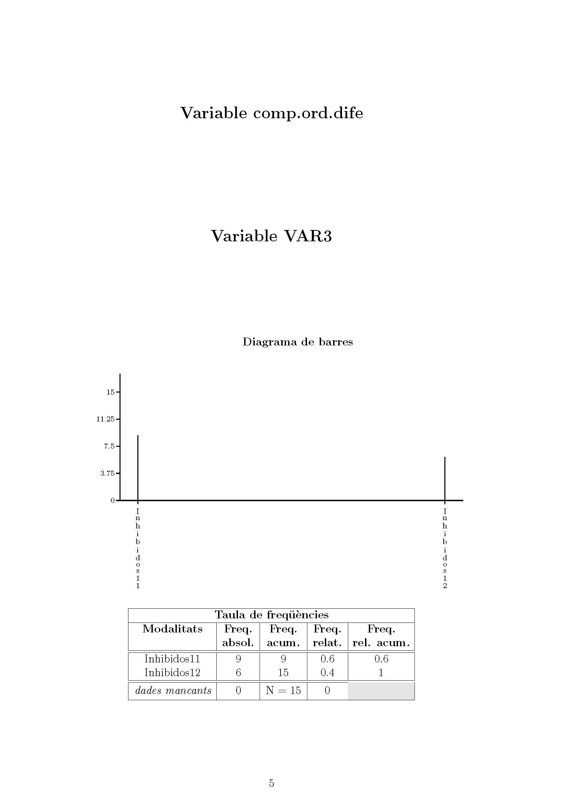

Figure-7

Figure-7 shows the composition of P2-6={inhibidos11, inhibidos12}. The boxplot-based induction rules is applied for every variable in P2-6 and the knowledge base is BC4 (listed in ‘Annex V’). Table-5 shows the quality of the rules:

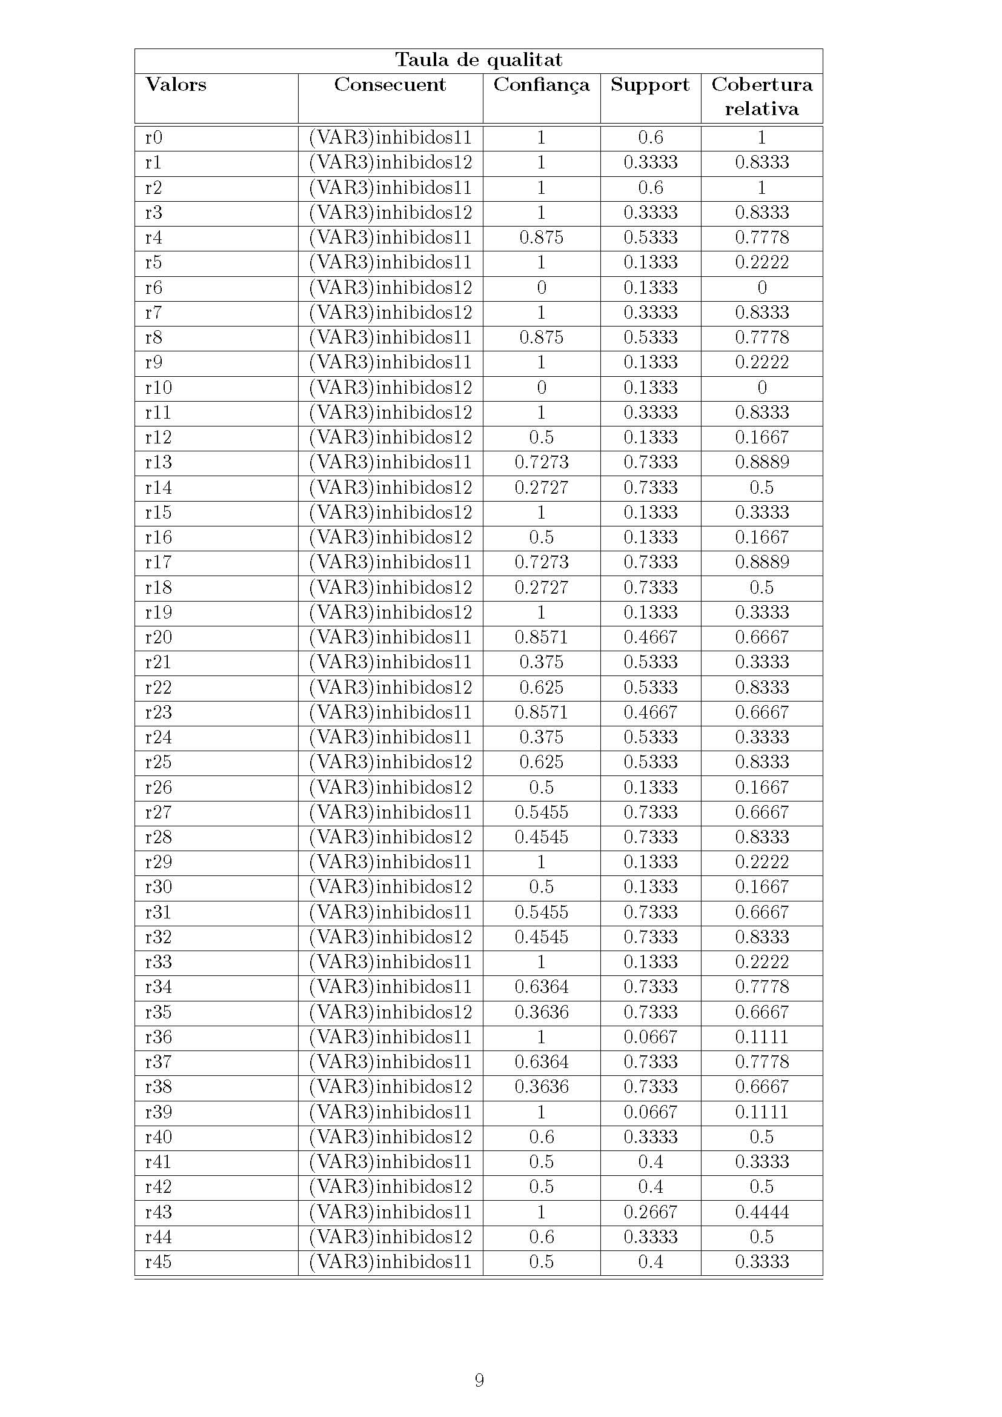

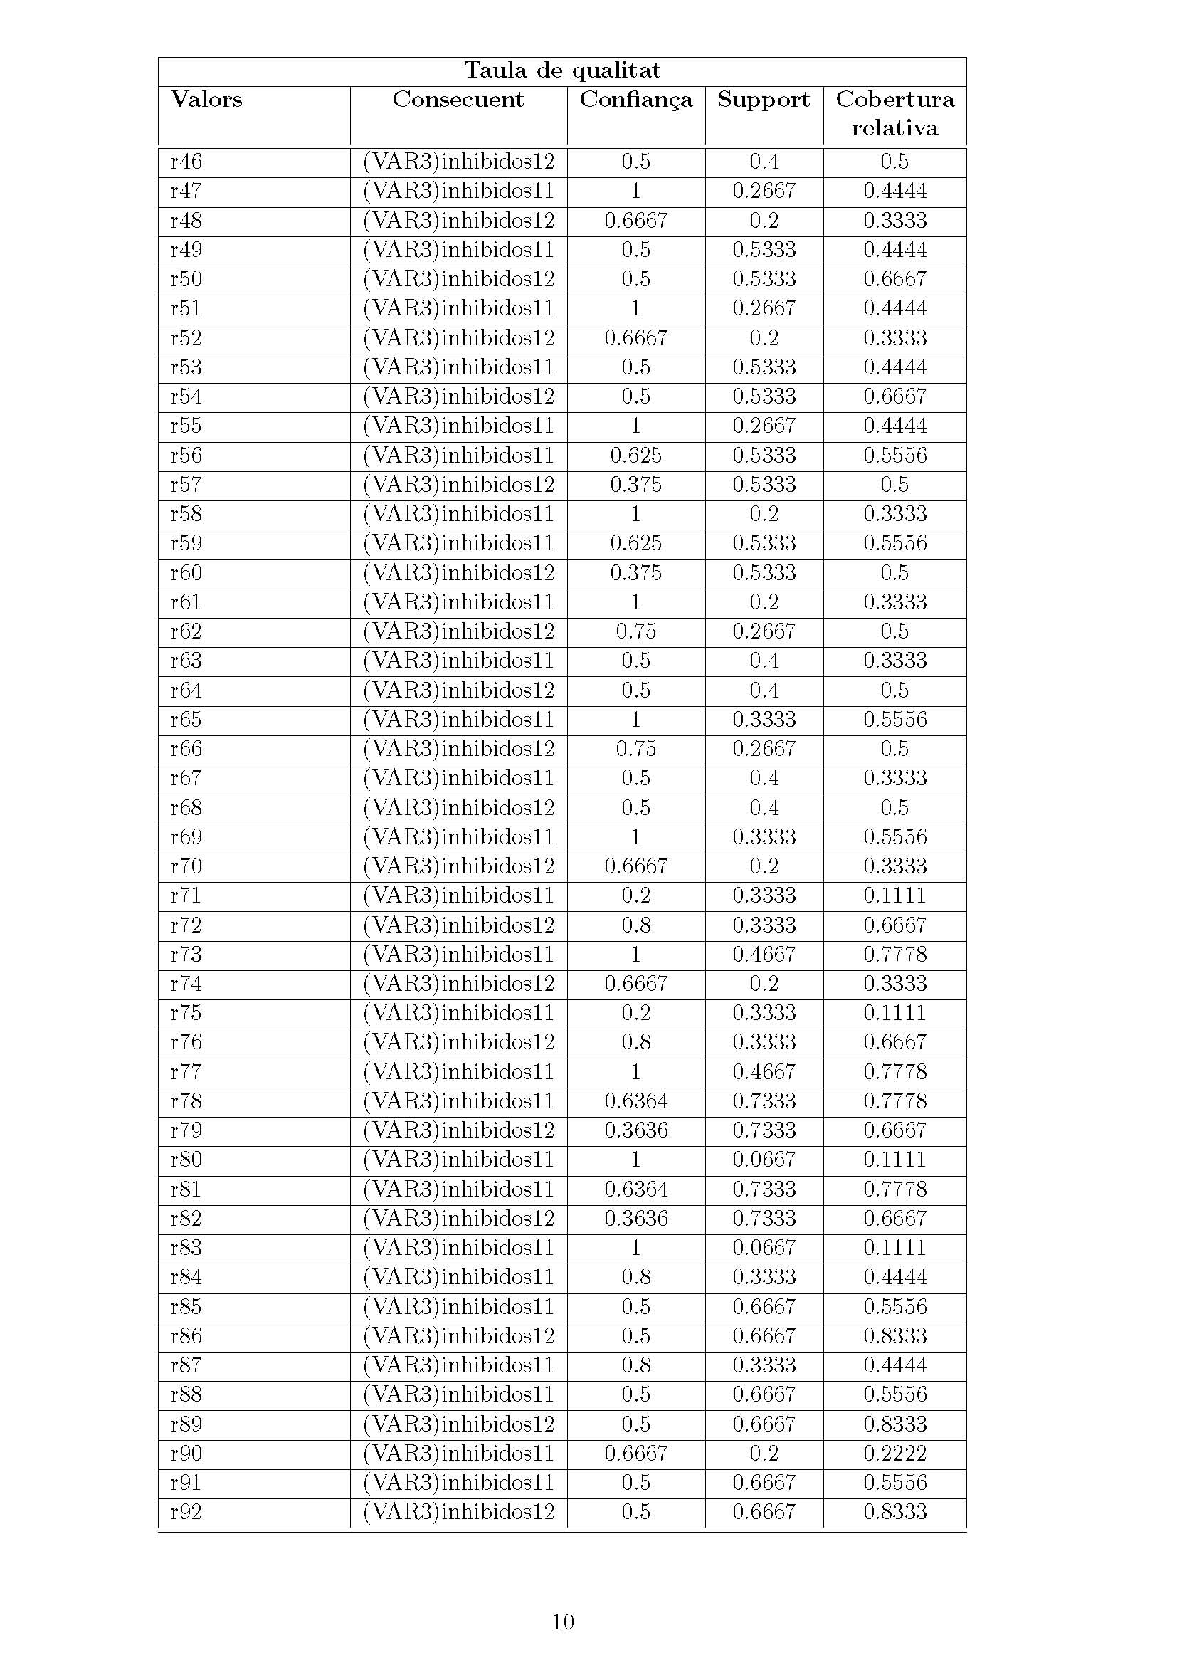

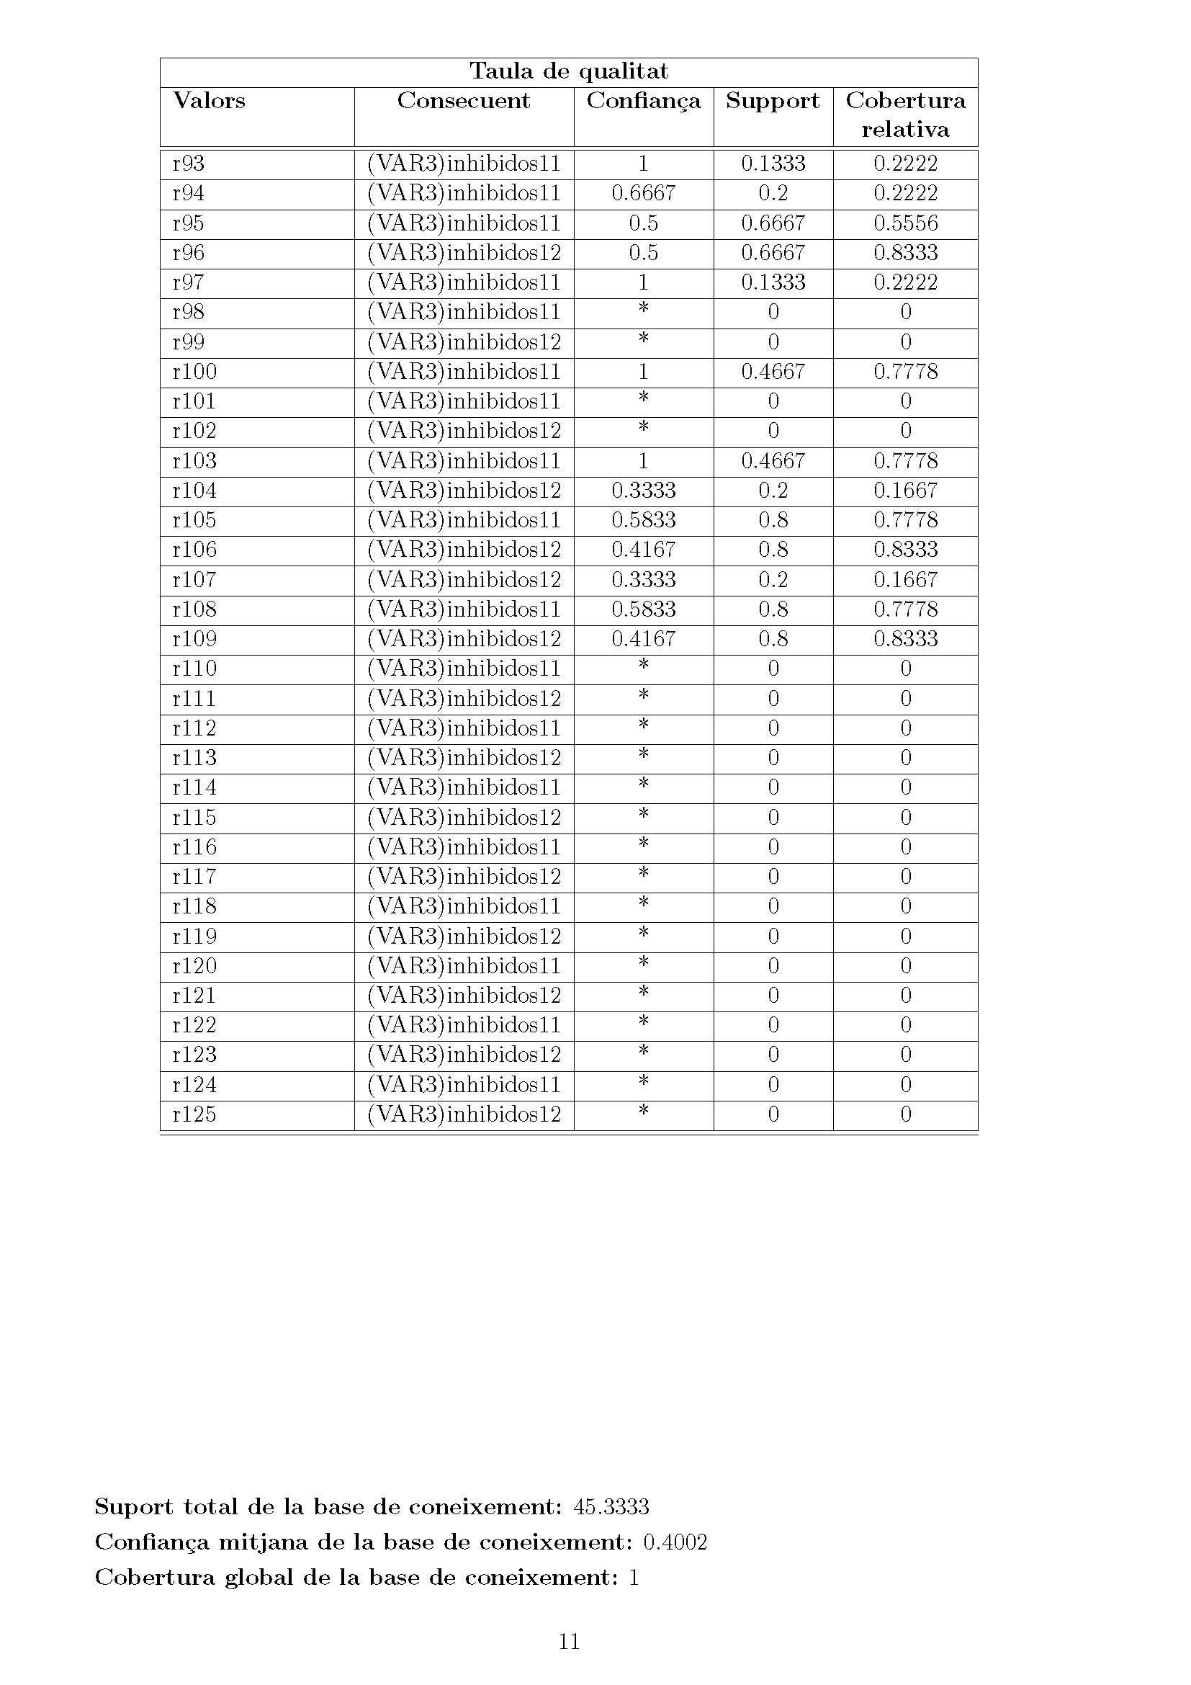

Table-5

The rules with ‘Max Confianca’ and ‘Max Cobertura Relativa’ in table-5.

For **inhibidos11**: (Max Confianca = 1) and (Max Cobertura Relativa = 1)

* r0 >> ((TAS.omis.post => 0) ᴧ (TAS.omis.post <= 3))
* r2 >> ((TAS.omis.dife => -10) ᴧ (TAS.omis.dife <= -7))

For **inhibidos12**: (Max Confianca = 1) and (Max Cobertura relative = 0.8333)

* r1 >> ((TAS.omis.post > 4) ᴧ (TAS.omis.post <= 10))
* r3 >> ((TAS.omis.dife > -6) ᴧ (TAS.omis.dife <= 0))
* r7 >> (TAS.error.post > 4) ᴧ (TAS.error.post <= 10))
* r11 >> (TAS.error.dife > -6) ᴧ (TAS.error.dife <=0))

**BL & Partial CWA:**

* inhibidos11:

(r0 ᴧ r2) ᴠ ¬(r7 ᴧ r11) (10.25)

(((TAS.omis.post => 0) ᴧ (TAS.omis.post <= 3)) ᴧ ((TAS.omis.dife => -10) ᴧ (TAS.omis.dife <= -7))) ᴠ ¬ (((TAS.error.post > 4) ᴧ (TAS.error.post <= 10)) ᴧ (TAS.error.dife > -6) ᴧ (TAS.error.dife <=0)))

* inhibidos12:

(r1 ᴠ r3 ᴠ r7 ᴠ r11) (10.28)

(((TAS.omis.post > 4) ᴧ (TAS.omis.post <= 10)) ᴠ ((TAS.omis.dife > -6) ᴧ (TAS.omis.dife <= 0)) ᴠ ((TAS.error.post > 4) ᴧ (TAS.error.post <= 10)) ᴠ ((TAS.error.dife > -6) ᴧ (TAS.error.dife <=0)))

**3.6. Final Solution for BL&Partial CWA**

After selecting rules at every steps, we can build the final solution for BL&Partial CWA as below. Every class appends the concepts associated to it and all ancestor classes in the dendrogram, upt to the root of the tree.

**34: C0 ᴧ 34**

[(((Stroop.p.c.post => 0) ᴧ (Stroop.p.c.post <= 0)) ᴧ ((Stroop.int.post => -25) ᴧ (Stroop.int.post <= -25)))] ᴧ [((B.d.i.dife => -1) ᴧ (B.d.i.dife <= -1)) ᴠ¬ ((B.v.rev.post => 0) ᴧ (B.v.rev.post <= 7))]

**graves9: C0 ᴧ graves 13 ᴧ graves 9**

[(((Stroop.p.c.post => 0) ᴧ (Stroop.p.c.post <= 0)) ᴧ ((Stroop.int.post => -25) ᴧ (Stroop.int.post <= -25)))] ᴧ [((B.v.rev.post => 0) ᴧ (B.v.rev.post <= 7)) ᴠ¬ ((B.d.i.dife => -1) ᴧ (B.d.i.dife <= -1))] ᴧ [((den.vv.post => 0) ᴧ (den.vv.post <= 0)) ᴠ ¬ (((B.d.d.post => 0) ᴧ (B.d.d.post <= 0)) ᴧ ((B.d.i.dife => 0) ᴧ (B.d.i.dife <= 0)) ᴧ ((B.d.i.post => 0) ᴧ (B.d.i.post <= 0)) ᴧ ((B.d.d.dife => 0) ᴧ (B.d.d.dife <= 0)))]

**graves12: C0 ᴧ graves 13 ᴧ graves 12**

[(((Stroop.p.c.post => 0) ᴧ (Stroop.p.c.post <= 0)) ᴧ ((Stroop.int.post => -25) ᴧ (Stroop.int.post <= -25)))] ᴧ [((B.v.rev.post => 0) ᴧ (B.v.rev.post <= 7)) ᴠ¬ ((B.d.i.dife => -1) ᴧ (B.d.i.dife <= -1))] ᴧ [(((B.d.d.post => 0) ᴧ (B.d.d.post <= 0)) ᴧ ((B.d.i.dife => 0) ᴧ (B.d.i.dife <= 0)) ᴧ ((B.d.i.post => 0) ᴧ (B.d.i.post <= 0)) ᴧ ((B.d.d.dife => 0) ᴧ (B.d.d.dife <= 0)) ᴧ ((den.vv.post => 2) ᴧ (den.vv.post <= 10)))]

**valorable14: C1 ᴧ valorable14**

[(((Stroop.p.c.post > 14) ᴧ (Stroopp.p.c.post < 60)) ᴠ ((Stroop.int.post => -18.89) ᴧ (Stroop.int.post <= 17.1)))] ᴧ [((B.d.d.dife => -1) ᴧ (B.d.d.dife <= 2)) ᴠ¬ ((B.m.c.p.p.dife > 5) ᴧ (B.m.c.p.p.dife <=16))]

**Inhibidos11: C1** **ᴧ inhibidos13 ᴧ inhibidos11**

[(((Stroop.p.c.post > 14) ᴧ (Stroopp.p.c.post < 60)) ᴠ ((Stroop.int.post => -18.89) ᴧ (Stroop.int.post <= 17.1)))] ᴧ [((B.d.d.dife > 3) ᴧ (B.d.d.dife <= 7)) ᴠ ((B.m.c.p.p.dife > 5) ᴧ (B.m.c.p.p.dife <=16))] ᴧ [(((TAS.omis.post => 0) ᴧ (TAS.omis.post <= 3)) ᴧ ((TAS.omis.dife => -10) ᴧ (TAS.omis.dife <= -7))) ᴠ ¬ (((TAS.error.post > 4) ᴧ (TAS.error.post <= 10)) ᴧ (TAS.error.dife > -6) ᴧ (TAS.error.dife <=0)))]

**Inhibidos12: C1** **ᴧ inhibidos13 ᴧ inhibidos12**

[(((Stroop.p.c.post > 14) ᴧ (Stroopp.p.c.post < 60)) ᴠ ((Stroop.int.post => -18.89) ᴧ (Stroop.int.post <= 17.1)))] ᴧ [((B.d.d.dife > 3) ᴧ (B.d.d.dife <= 7)) ᴠ ((B.m.c.p.p.dife > 5) ᴧ (B.m.c.p.p.dife <=16))] ᴧ [(((TAS.omis.post > 4) ᴧ (TAS.omis.post <= 10)) ᴠ ((TAS.omis.dife > -6) ᴧ (TAS.omis.dife <= 0)) ᴠ ((TAS.error.post > 4) ᴧ (TAS.error.post <= 10)) ᴠ ((TAS.error.dife > -6) ᴧ (TAS.error.dife <=0)))]

**34: C0 ᴧ 34**

[(Stroop.p.c.post ϵ [0, 0]) ᴧ (Stroop.int.post ϵ [-25, -25])] ᴧ [(B.d.i.dife ϵ [-1, -1]) ᴠ¬ (B.v.rev.post ϵ [0, 7])]

**graves9: C0 ᴧ graves 13 ᴧ graves 9**

[(Stroop.p.c.post ϵ [0, 0]) ᴧ (Stroop.int.post ϵ [-25, -25])] ᴧ [(B.v.rev.post ϵ [0, 7]) ᴠ¬ (B.d.i.dife ϵ [-1, -1])] ᴧ [(den.vv.post ϵ [0, 0]) ᴠ¬ ((B.d.d.post ϵ [0, 0]) ᴧ (B.d.i.dife ϵ [0, 0]) ᴧ (B.d.i.post ϵ [0, 0]) ᴧ (B.d.d.dife ϵ [0, 0]))]

**graves12: C0 ᴧ graves 13 ᴧ graves 12**

[(Stroop.p.c.post ϵ [0, 0]) ᴧ (Stroop.int.post ϵ [-25, -25])] ᴧ [(B.v.rev.post ϵ [0, 7]) ᴠ¬ (B.d.i.dife ϵ [-1, -1])] ᴧ [(B.d.d.post ϵ [0, 0]) ᴧ (B.d.i.dife ϵ [0, 0]) ᴧ (B.d.i.post ϵ [0, 0]) ᴧ (B.d.d.dife ϵ [0, 0]) ᴧ (den.vv.post ϵ [2, 10])]

**valorable14: c1 ᴧ valorable14**

[(Stroop.p.c.post ϵ [14, 60]) ᴠ (Stroop.int.post ϵ [-18.89, 17.1])] ᴧ [(B.d.d.dife ϵ [-1, 2]) ᴠ¬ (B.m.c.p.p.dife ϵ [5, 16])]

**Inhibidos11: C1** **ᴧ inhibidos13 ᴧ inhibidos11**

[(Stroop.p.c.post ϵ [14, 60]) ᴠ (Stroop.int.post ϵ [-18.89, 17.1])] ᴧ [(B.d.d.dife ϵ [3, 7]) ᴠ (B.m.c.p.p.dife ϵ [5, 16])] ᴧ [(TAS.omis.post ϵ [0, 3]) ᴧ (TAS.omis.dife ϵ [-10, -7]) ᴠ ¬ ((TAS.error.post ϵ [4, 10]) ᴧ (TAS.error.dife ϵ [-6, 0]))]

**Inhibidos12: C1** **ᴧ inhibidos13 ᴧ inhibidos12**

[(Stroop.p.c.post ϵ [14, 60]) ᴠ (Stroop.int.post ϵ [-18.89, 17.1])] ᴧ [(B.d.d.dife ϵ [3, 7]) ᴠ (B.m.c.p.p.dife ϵ [5, 16])] ᴧ [(TAS.omis.post ϵ [4, 10]) ᴠ (TAS.omis.dife ϵ [-6, 0]) ᴠ (TAS.error.post ϵ [4, 10]) ᴠ (TAS.error.dife ϵ [-6, 0])]

1. **Description of BL+G&CWA**

For each of the 2 classes:

Find all the rules that have "Confiança = 1" and maximum "Cobertura relativa"

a) If a single rule for each class is found, being Ai and Aj their antecedents,

* if they refer to the same variable,

o if ("Cobertura relativa" if the rule with Ai) > ("Cobertura relativa" if the rule with Aj), then apply (10.29) and (10.30)

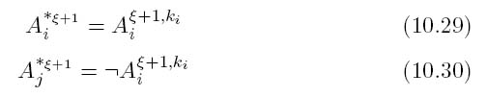

o else apply (10.31) and (10.32)

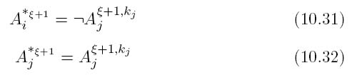

* else (10.33 and 10.34 ‘which are the same as 10.23 and 10.24’)

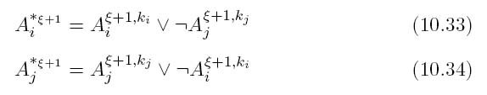

b) if there are many rules

* If rules have "Confiança = 1" and "Cobertura relativa = 1" chain their antecedents as it is said in (10.35) and (10.36)

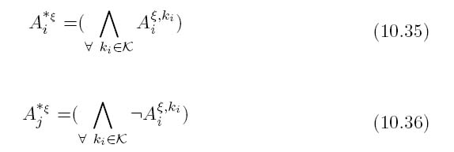

* else chain the antecedents as it is said in (10.37) and (10.38)

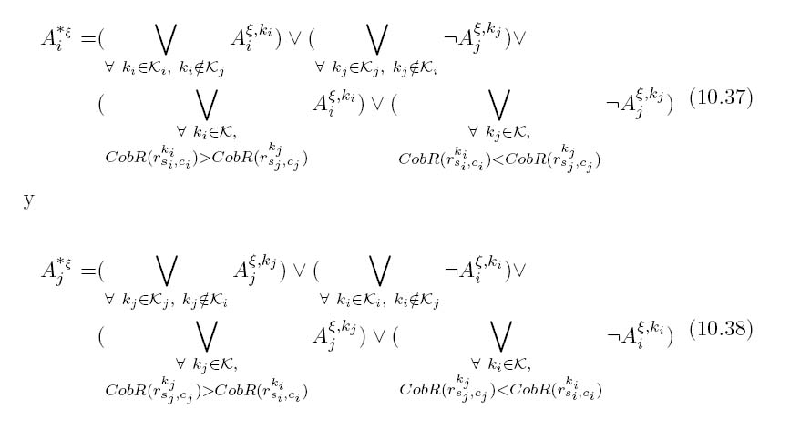

(Notice that, out of the four terms in each expression, the first one specifies rules that do not share the same variable with the rules of the other class, the second term refers rules that do not share the same variable with any of the rules from the first class, the third term refers rules with greater "Cobertura relativa" than any of those of the second class, and the forth is selecting those with greater "Cobertura relativa" than any of those of the first class)

**5.Validation of BL + G & CWA**

**5.1. First Iteration**

The partitions and classes of every iteration are the same as in previous case, since all of them derive from the same dendrogram.

The rules with ‘Max Confianca’ and ‘Max Cobertura Relativa’ in table-1.

For **C0**: (Max Confianca = 1) and (Max Cobertura Relativa = 1)

* r14 >> ((Stroop.p.c.post => 0) ᴧ (Stroop.p.c.post <= 0))
* r94 >> ((Stroop.int.post => -25) ᴧ (Stroop.int.post <= -25))

For **C1**: (Max Confianca = 1) and (Max Cobertura relative = 0.9677)

* r15 >> ((Stroop.p.c.post > 14) ᴧ (Stroopp.p.c.post < 60))
* r95 >> ((Stroop.int.post => -18.89) ᴧ (Stroop.int.post <= 17.1))

**BL + G & CWA:**

* AC02 ->> (((Stroop.p.c.post => 0) ᴧ (Stroop.p.c.post <= 0)) ᴧ ((Stroop.int.post => -25) ᴧ (Stroop.int.post <= -25)))
* AC12 ->> ¬ (((Stroop.p.c.post => 0) ᴧ (Stroop.p.c.post <= 0)) ᴧ ((Stroop.int.post => -25) ᴧ (Stroop.int.post <= -25)))

**5.2. Second Iteration: class ‘C0’ from the previous iteration is split in two classes -> [graves13 , 34]**

Data matrix with C0 elements is used

**BC1:**

For **graves13**: (Max Confianca = 1) and (Max Cobertura Relativa = 1)

* r67 >> ((B.v.rev.post => 0) ᴧ (B.v.rev.post <= 7))

For **34**: (Max Confianca = 1) and (Max Cobertura relative = 1)

* r32 >> ((B.d.i.dife => -1) ᴧ (B.d.i.dife <= -1))

**Concepts provided by BL + G & CWA are:**

* Graves 13:

r67 ᴠ¬ r32 (10.33)

((B.v.rev.post => 0) ᴧ (B.v.rev.post <= 7)) ᴠ¬ ((B.d.i.dife => -1) ᴧ (B.d.i.dife <= -1))

* 34:

R32 ᴠ¬ r67 (10.34)

((B.d.i.dife => -1) ᴧ (B.d.i.dife <= -1)) ᴠ¬ ((B.v.rev.post => 0) ᴧ (B.v.rev.post <= 7))

**5.3. Third Iteration: class ‘graves13’ from the previous iteration is split in two classes -> [graves12 , graves9]**

ELements for graves13 are only considered

**BC2:**

For **graves12**: (Max Confianca = 1) and (Max Cobertura Relativa = 1)

* r22 >> ((B.d.d.post => 0) ᴧ (B.d.d.post <= 0))
* r24 >> ((B.d.d.dife => 0) ᴧ (B.d.d.dife <= 0))
* r26 >> ((B.d.i.post => 0) ᴧ (B.d.i.post <= 0))
* r28 >> ((B.d.d.dife => 0) ᴧ (B.d.d.dife <= 0))
* r92 >>((den.vv.post => 2) ᴧ (den.vv.post <= 0))

For **graves9**: (Max Confianca = 1) and (Max Cobertura relative = 1)

* r94 >> ((den.vv.post => 0) ᴧ (den.vv.post <= 0))

**Concepts according to BL + G & CWA are:**

* graves12:

(r22 ᴧ r24 ᴧ r26 ᴧ 28 ᴧ 92) (10.35)

(((B.d.d.post => 0) ᴧ (B.d.d.post <= 0)) ᴧ ((B.d.d.dife => 0) ᴧ (B.d.d.dife <= 0)) ᴧ ((B.d.i.post => 0) ᴧ (B.d.i.post <= 0)) ᴧ ((B.d.d.dife => 0) ᴧ (B.d.d.dife <= 0)) ᴧ ((den.vv.post => 2) ᴧ (den.vv.post <= 0)))

* graves9:

¬ (r22 ᴧ r24 ᴧ r26 ᴧ 28 ᴧ 92) (10.36)

¬ (((B.d.d.post => 0) ᴧ (B.d.d.post <= 0)) ᴧ ((B.d.d.dife => 0) ᴧ (B.d.d.dife <= 0)) ᴧ ((B.d.i.post => 0) ᴧ (B.d.i.post <= 0)) ᴧ ((B.d.d.dife => 0) ᴧ (B.d.d.dife <= 0)) ᴧ ((den.vv.post => 2) ᴧ (den.vv.post <= 0)))

**5.4. Forth Iteration: ‘C1’ split in two classes -> [inhibidos13 , valorables14]**

Only elements of C1 are considered

**BC3:**

For **valorables14**: (Max Confianca = 1) and (Max Cobertura Relativa = 1)

* r32 >> ((B.d.d.dife => -1) ᴧ (B.d.d.dife <= 2))

For **inhibidos13**: (Max Confianca = 1) and (Max Cobertura relative = 0.9333)

* r33 >> ((B.d.d.dife > 3) ᴧ (B.d.d.dife <= 7))
* r56 >> ((B.m.c.p.p.dife > 5) ᴧ (B.m.c.p.p.dife <=16))

**Concepts according to BL + G & CWA are:**

* valorable14:

r32 (10.35)

((B.d.d.dife => -1) ᴧ (B.d.d.dife <= 2))

* inhibidos13:

(r56) ᴠ (¬r32) (10.38)

((B.m.c.p.p.dife > 5) ᴧ (B.m.c.p.p.dife <=16)) ᴠ ¬ ((B.d.d.dife => -1) ᴧ (B.d.d.dife <= 2))

**5.5. Fifth Iteration: class ‘inhibidos13’ from the previous iteration is split in two classes -> [inhibidos11 , inhibidos12]**

Only elements for inhibidos13 are used

**BC4:**

For **inhibidos11**: (Max Confianca = 1) and (Max Cobertura Relativa = 1)

* r0 >> ((TAS.omis.post => 0) ᴧ (TAS.omis.post <= 3))
* r2 >> ((TAS.omis.dife => -10) ᴧ (TAS.omis.dife <= -7))

For **inhibidos12**: (Max Confianca = 1) and (Max Cobertura relative = 0.8333)

* r1 >> ((TAS.omis.post > 4) ᴧ (TAS.omis.post <= 10))
* r3 >> ((TAS.omis.dife > -6) ᴧ (TAS.omis.dife <= 0))
* r7 >> ((TAS.error.post > 4) ᴧ (TAS.error.post <= 10))
* r11 >> ((TAS.error.dife > -6) ᴧ (TAS.error.dife <=0))

**Concepts for BL + G & CWA are:**

* inhibidos11:

(r0 ᴧ r2) ᴧ (¬r7 ᴧ ¬r11) (10.35)

((TAS.omis.post => 0) ᴧ (TAS.omis.post <= 3)) ᴧ ((TAS.omis.dife => -10) ᴧ (TAS.omis.dife <= -7)) ᴧ (¬ ((TAS.error.post > 4) ᴧ (TAS.error.post <= 10)) ᴧ (¬ ((TAS.error.dife > -6) ᴧ (TAS.error.dife <=0)))

* inhibidos12:

(r7 ᴠ r11) ᴧ (¬r0 ᴠ ¬r2) (10.38)

(((TAS.error.post > 4) ᴧ (TAS.error.post <= 10)) ᴠ ((TAS.error.dife > -6) ᴧ (TAS.error.dife <=0))) ᴧ (¬ ((TAS.omis.post => 0) ᴧ (TAS.omis.post <= 3)) ᴠ ¬ ((TAS.omis.dife => -10) ᴧ (TAS.omis.dife <= -7)))

**5.6. Final Solution for BL+G&CWA**

After building concepts for every subclass, the final description of the classes includes the inheritance of the ancestor classes as bellow:

**34: C0 ᴧ 34**

[(((Stroop.p.c.post => 0) ᴧ (Stroop.p.c.post <= 0)) ᴧ ((Stroop.int.post => -25) ᴧ (Stroop.int.post <= -25)))] ᴧ [((B.d.i.dife => -1) ᴧ (B.d.i.dife <= -1)) ᴠ¬ ((B.v.rev.post => 0) ᴧ (B.v.rev.post <= 7))]

**graves9: C0 ᴧ graves 13 ᴧ graves 9**

[(((Stroop.p.c.post => 0) ᴧ (Stroop.p.c.post <= 0)) ᴧ ((Stroop.int.post => -25) ᴧ (Stroop.int.post <= -25)))] ᴧ [((B.v.rev.post => 0) ᴧ (B.v.rev.post <= 7)) ᴠ¬ ((B.d.i.dife => -1) ᴧ (B.d.i.dife <= -1))] ᴧ [¬ (((B.d.d.post => 0) ᴧ (B.d.d.post <= 0)) ᴧ ((B.d.d.dife => 0) ᴧ (B.d.d.dife <= 0)) ᴧ ((B.d.i.post => 0) ᴧ (B.d.i.post <= 0)) ᴧ ((B.d.d.dife => 0) ᴧ (B.d.d.dife <= 0)) ᴧ ((den.vv.post => 2) ᴧ (den.vv.post <= 0)))]  
**graves12: C0 ᴧ graves 13 ᴧ graves 12**

[(((Stroop.p.c.post => 0) ᴧ (Stroop.p.c.post <= 0)) ᴧ ((Stroop.int.post => -25) ᴧ (Stroop.int.post <= -25)))] ᴧ [((B.v.rev.post => 0) ᴧ (B.v.rev.post <= 7)) ᴠ¬ ((B.d.i.dife => -1) ᴧ (B.d.i.dife <= -1))] ᴧ [(((B.d.d.post => 0) ᴧ (B.d.d.post <= 0)) ᴧ ((B.d.d.dife => 0) ᴧ (B.d.d.dife <= 0)) ᴧ ((B.d.i.post => 0) ᴧ (B.d.i.post <= 0)) ᴧ ((B.d.d.dife => 0) ᴧ (B.d.d.dife <= 0)) ᴧ ((den.vv.post => 2) ᴧ (den.vv.post <= 0)))]

**valorable14: c1 ᴧ valorable14**

¬ [(((Stroop.p.c.post => 0) ᴧ (Stroop.p.c.post <= 0)) ᴧ ((Stroop.int.post => -25) ᴧ (Stroop.int.post <= -25)))] ᴧ [((B.d.d.dife => -1) ᴧ (B.d.d.dife <= 2))]

**inhibidos11: C1 ᴧ inhibidos13 ᴧ inhibidos11**

¬ [(((Stroop.p.c.post => 0) ᴧ (Stroop.p.c.post <= 0)) ᴧ ((Stroop.int.post => -25) ᴧ (Stroop.int.post <= -25)))] ᴧ [((B.m.c.p.p.dife > 5) ᴧ (B.m.c.p.p.dife <=16)) ᴠ ¬ ((B.d.d.dife => -1) ᴧ (B.d.d.dife <= 2))] ᴧ [((TAS.omis.post => 0) ᴧ (TAS.omis.post <= 3)) ᴧ ((TAS.omis.dife => -10) ᴧ (TAS.omis.dife <= -7)) ᴧ (¬ ((TAS.error.post > 4) ᴧ (TAS.error.post <= 10)) ᴧ (¬ ((TAS.error.dife > -6) ᴧ (TAS.error.dife <=0)))]

**inhibidos12: C1 ᴧ inhibidos13 ᴧ inhibidos12**

¬ [(((Stroop.p.c.post => 0) ᴧ (Stroop.p.c.post <= 0)) ᴧ ((Stroop.int.post => -25) ᴧ (Stroop.int.post <= -25)))] ᴧ [((B.m.c.p.p.dife > 5) ᴧ (B.m.c.p.p.dife <=16)) ᴠ ¬ ((B.d.d.dife => -1) ᴧ (B.d.d.dife <= 2))] ᴧ [(((TAS.error.post > 4) ᴧ (TAS.error.post <= 10)) ᴠ ((TAS.error.dife > -6) ᴧ (TAS.error.dife <=0))) ᴧ (¬ ((TAS.omis.post => 0) ᴧ (TAS.omis.post <= 3)) ᴠ ¬((TAS.omis.dife => -10) ᴧ (TAS.omis.dife <= -7)))]

**34: C0 ᴧ 34**

[(Stroop.p.c.post ϵ [0, 0]) ᴧ (Stroop.int.post ϵ [-25, -25])] ᴧ [(B.d.i.dife ϵ [-1, -1]) ᴠ¬ (B.v.rev.post ϵ [0, 7])]

**gravise9: C0 ᴧ graves 13 ᴧ graves 9**

[(Stroop.p.c.post ϵ [0, 0]) ᴧ (Stroop.int.post ϵ [-25, -25])] ᴧ [(B.v.rev.post ϵ [0, 7]) ᴠ¬ (B.d.i.dife ϵ [-1, -1])] ᴧ [¬ ((B.d.d.post ϵ [0, 0]) ᴠ (B.d.d.dife ϵ [0, 0]) ᴠ (B.d.i.post ϵ [0, 0]) ᴠ (B.d.d.dife ϵ [0, 0]) ᴠ (den.vv.post ϵ [2, 0])]  
**graves12: C0 ᴧ graves 13 ᴧ graves 12**

[(Stroop.p.c.post ϵ [0, 0]) ᴧ (Stroop.int.post ϵ [-25, -25])] ᴧ [(B.v.rev.post ϵ [0, 7]) ᴠ¬ (B.d.i.dife ϵ [-1, -1])] ᴧ [(B.d.d.post ϵ [0, 0]) ᴧ (B.d.d.dife ϵ [0, 0]) ᴧ (B.d.i.post ϵ [0, 0]) ᴧ (B.d.d.dife ϵ [0, 0]) ᴧ (den.vv.post ϵ [2, 0])] **valorable14: c1 ᴧ valorable14**ϵ

¬ [(Stroop.p.c.post ϵ [0, 0]) ᴧ (Stroop.int.post ϵ [-25,-25])] ᴧ [(B.d.d.dife ϵ [-1, 2])]

**inhibidos11: C1 ᴧ inhibidos13 ᴧ inhibidos11**

¬ [(Stroop.p.c.post ϵ [0, 0]) ᴧ (Stroop.int.post ϵ [-25, -25])] ᴧ [(B.m.c.p.p.dife ϵ [5, 16]) ᴠ ¬ (B.d.d.dife ϵ [-1, 2])] ᴧ [(TAS.omis.post ϵ [0, 3]) ᴧ (TAS.omis.dife ϵ [-10, -7]) ᴧ (¬ (TAS.error.post ϵ [4, 10]) ᴧ (¬ (TAS.error.dife ϵ [-6, 0])]

**inhibidos12: C1 ᴧ inhibidos13 ᴧ inhibidos12**

¬ [(Stroop.p.c.post ϵ [0, 0]) ᴧ (Stroop.int.post ϵ [-25, -25])] ᴧ [(B.m.c.p.p.dife ϵ [5, 16]) ᴠ ¬ (B.d.d.dife ϵ [-1, 2])] ᴧ [(TAS.error.post ϵ [4, 10]) ᴠ (TAS.error.dife ϵ [-6, 0]) ᴧ (¬ (TAS.omis.post ϵ [0, 3]) ᴠ ¬ (TAS.omis.dife ϵ [-10, -7])]

**Annex I: BC0**

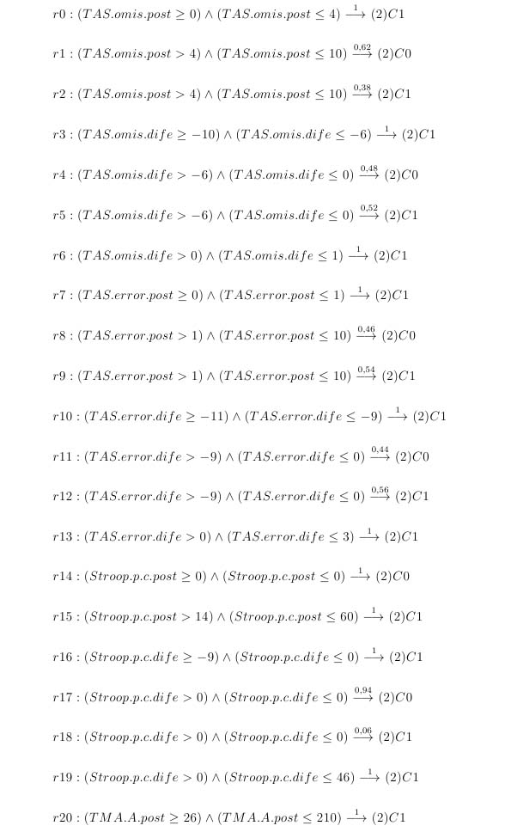

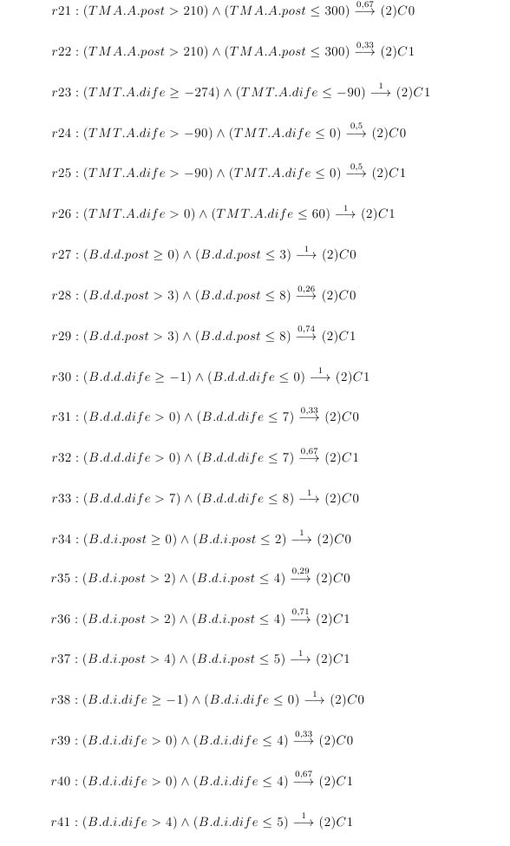

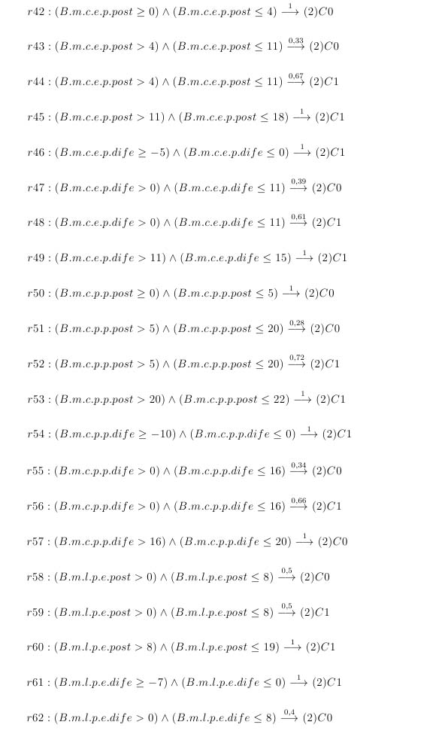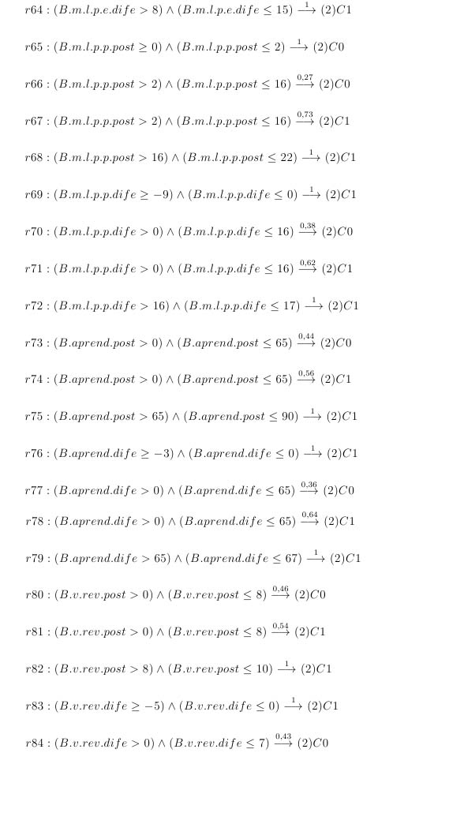

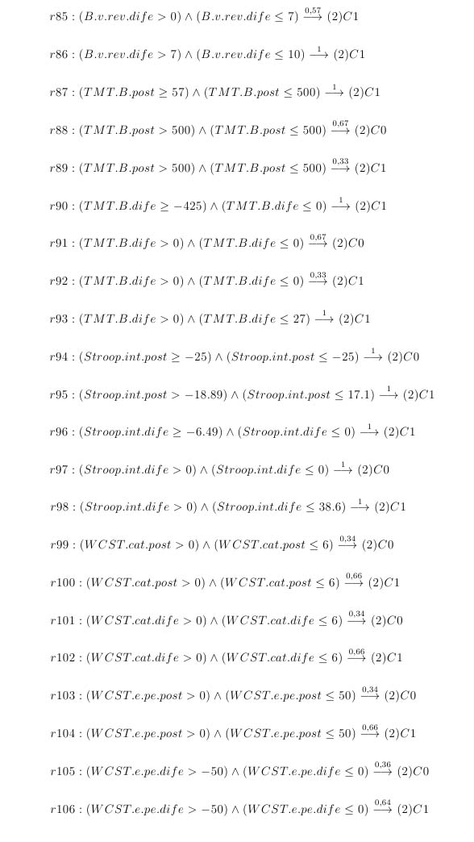

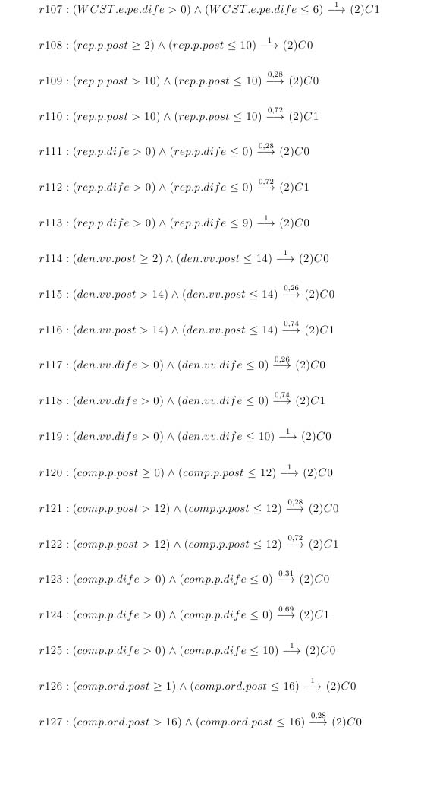

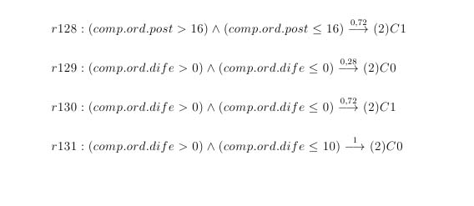

**Annex II: BC1**

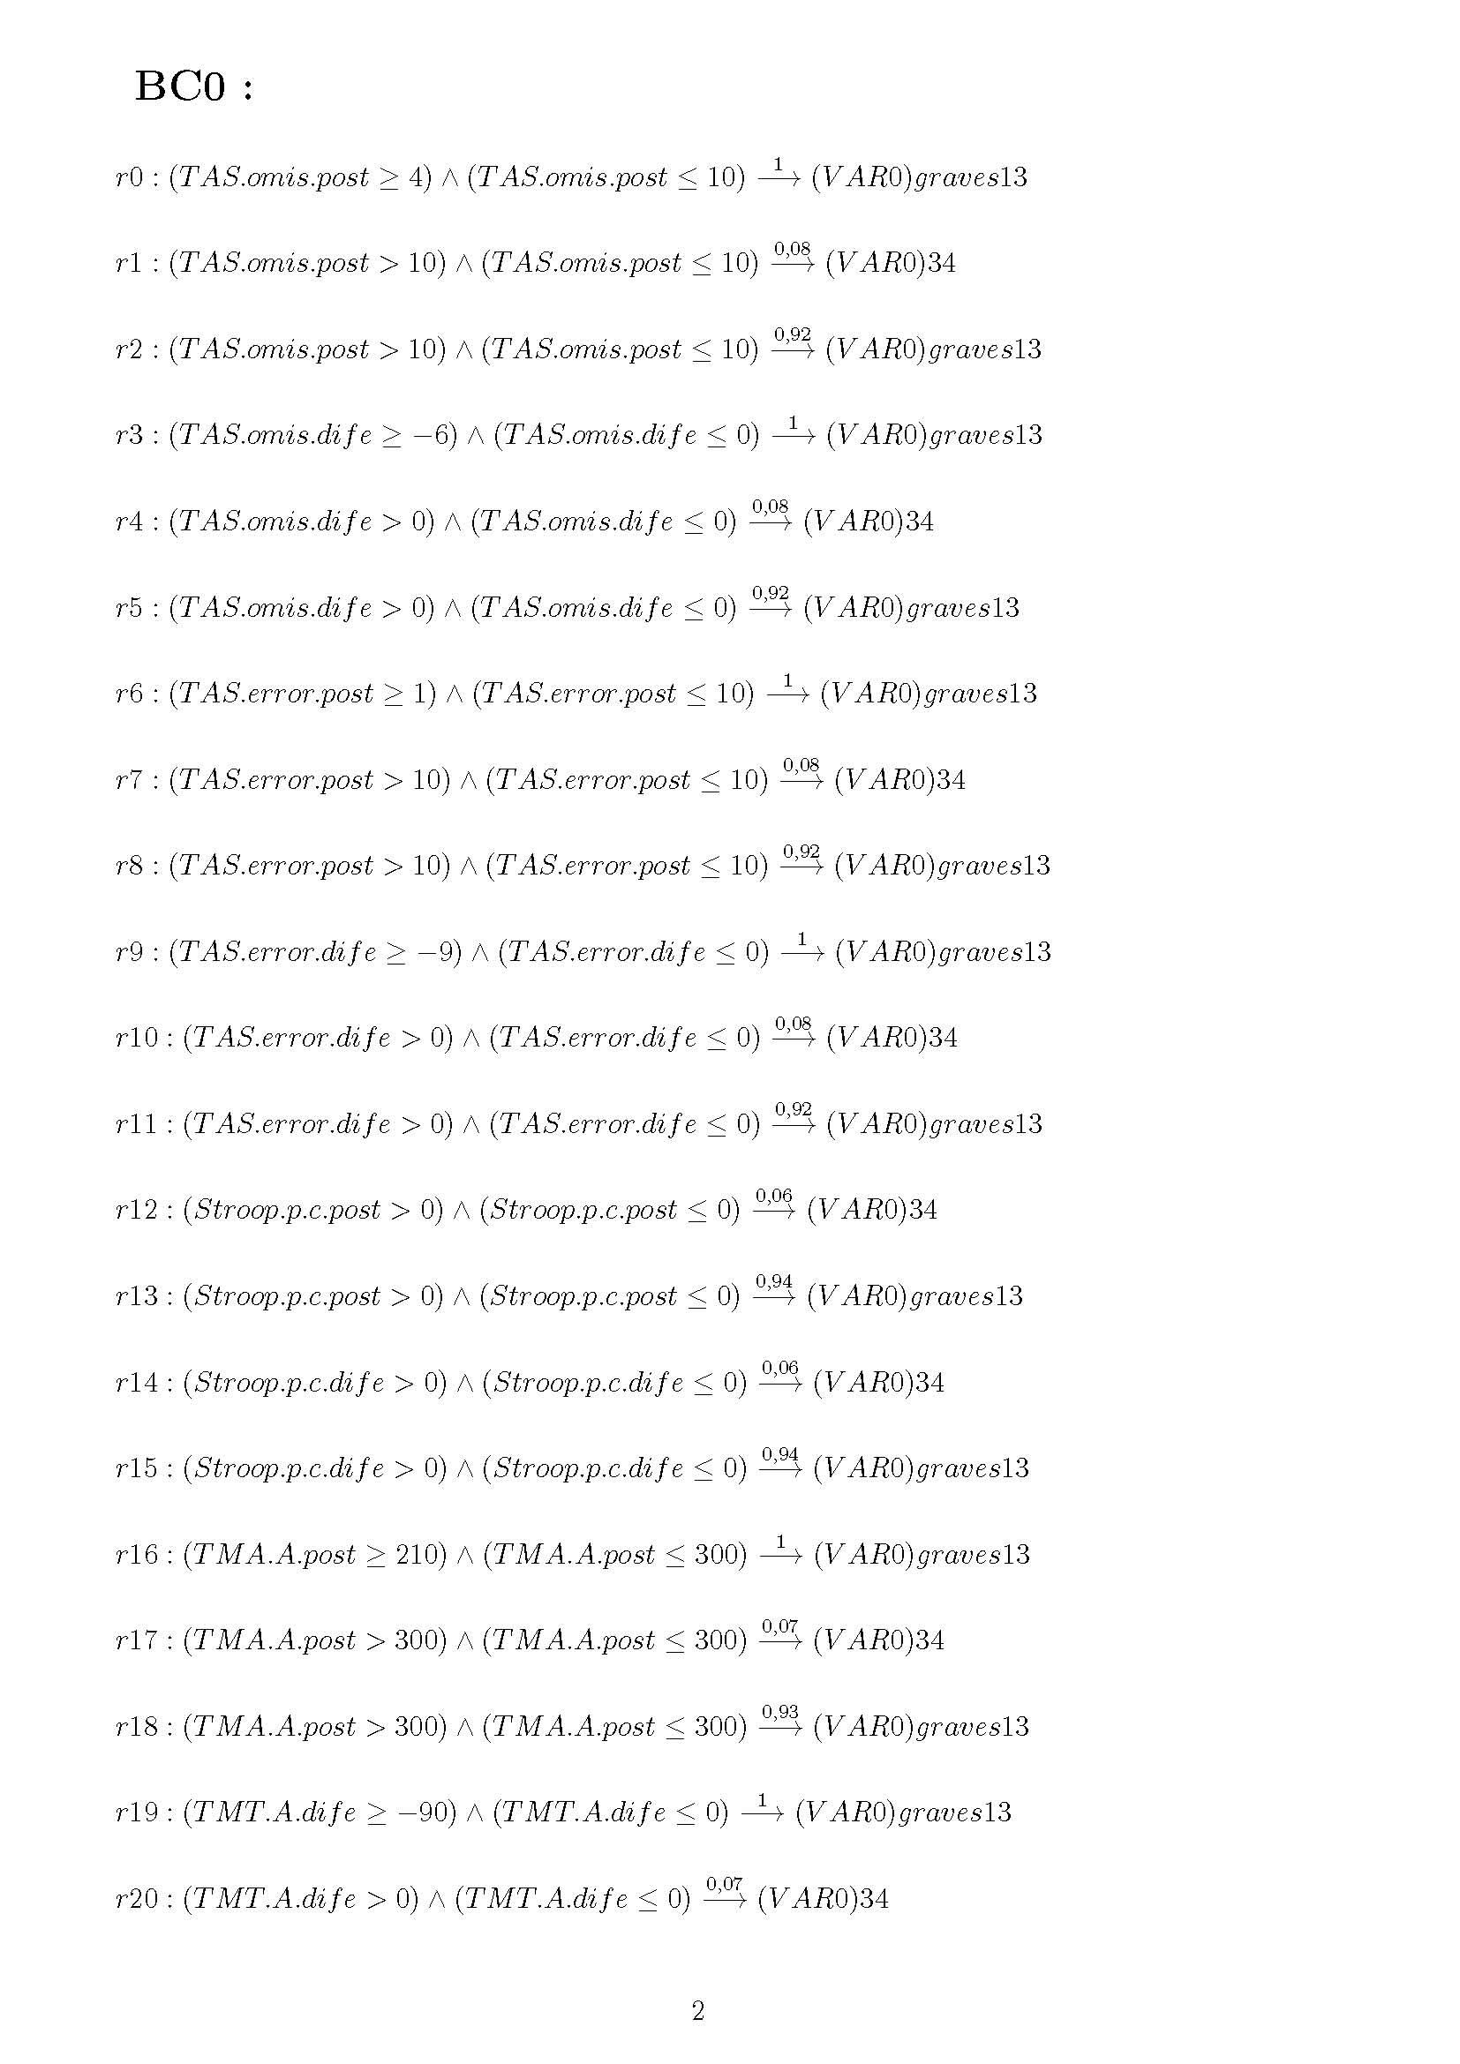

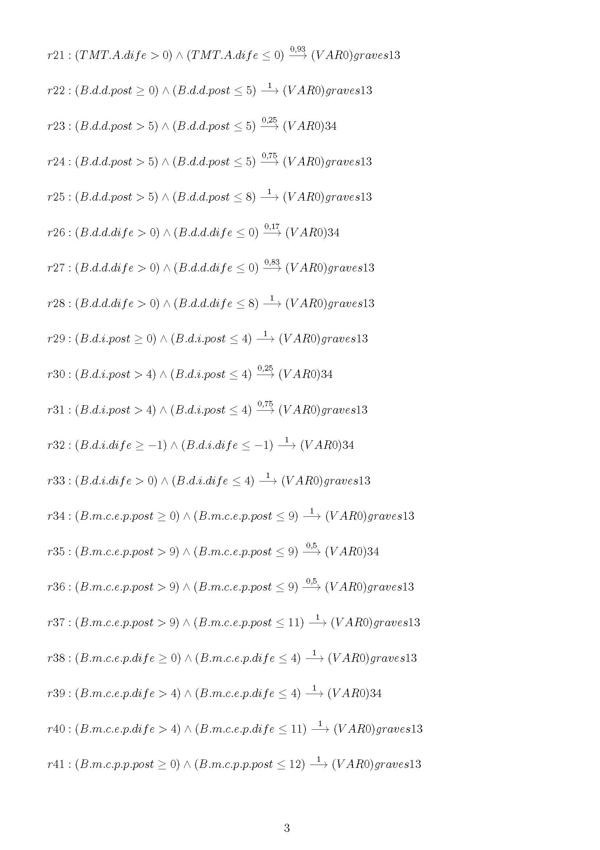

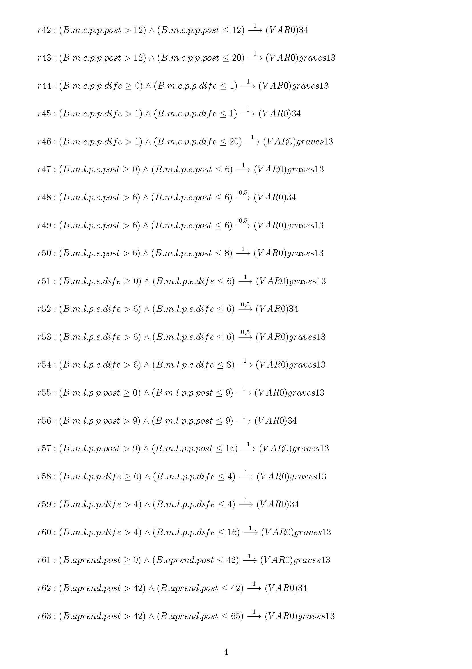

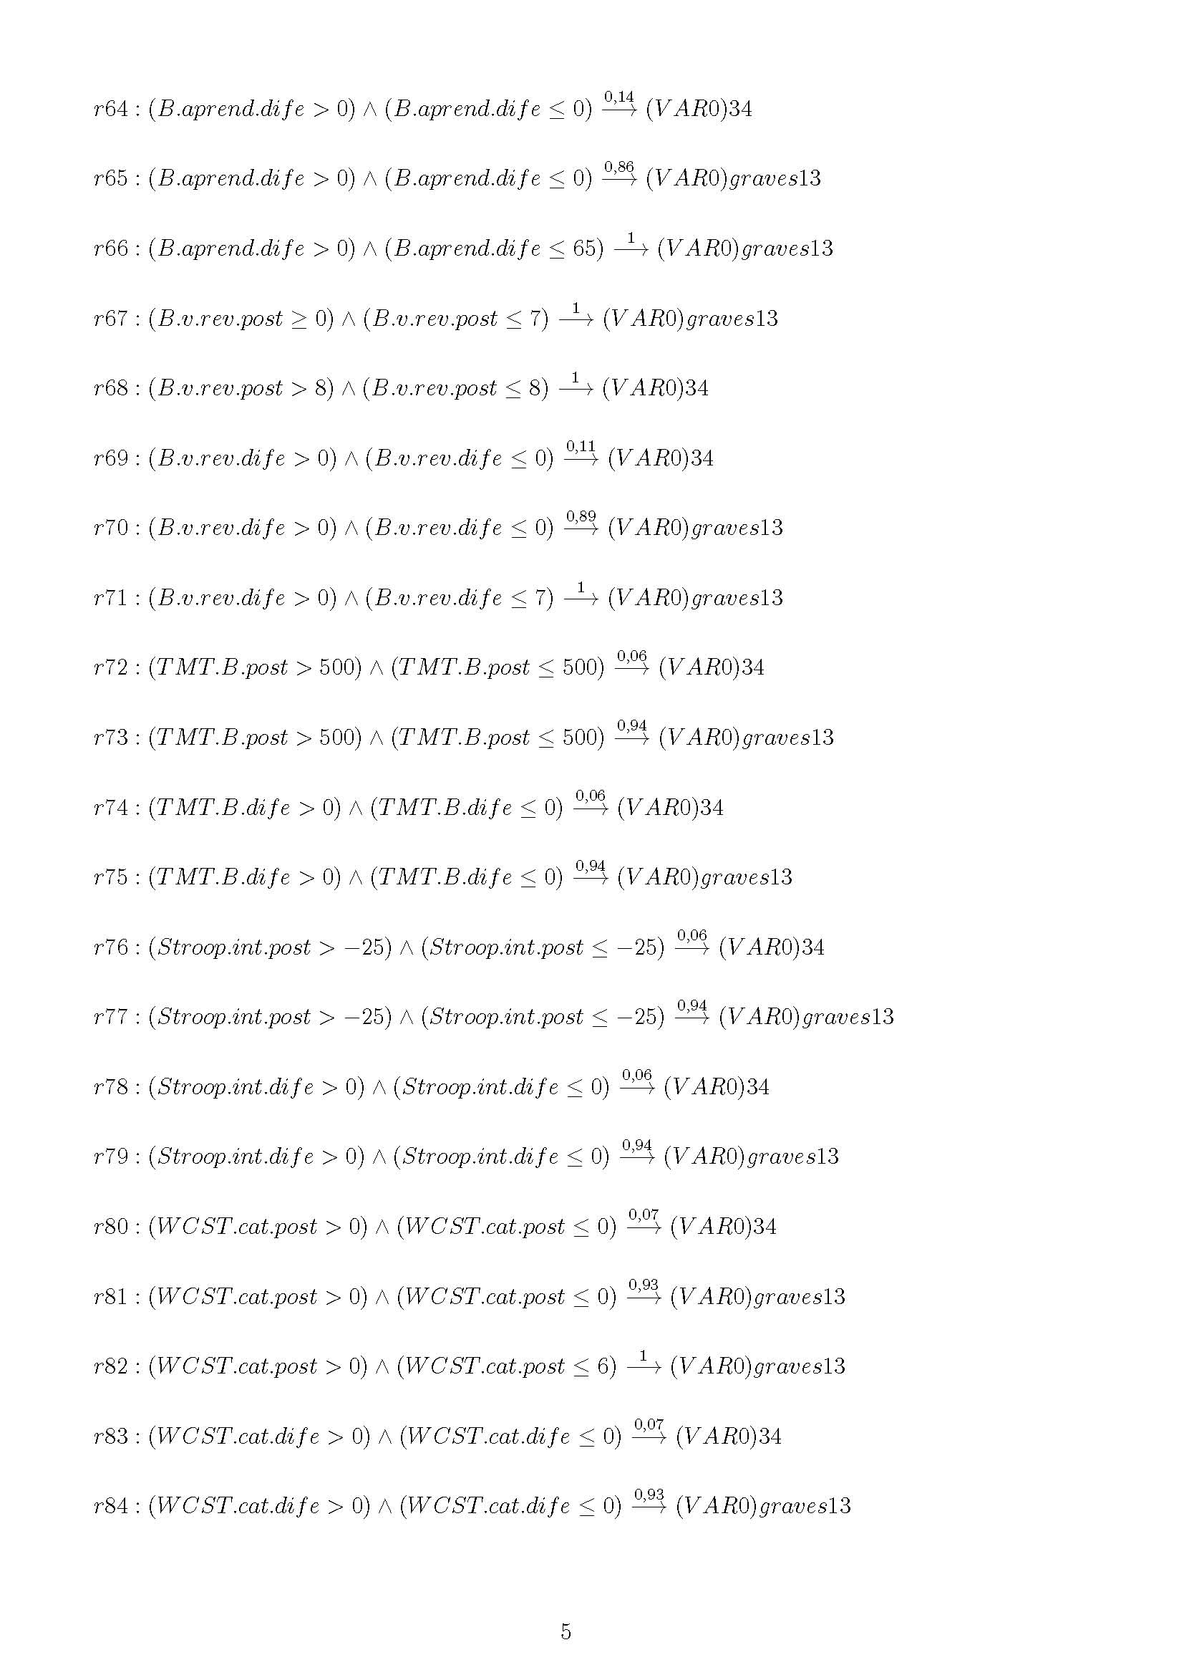

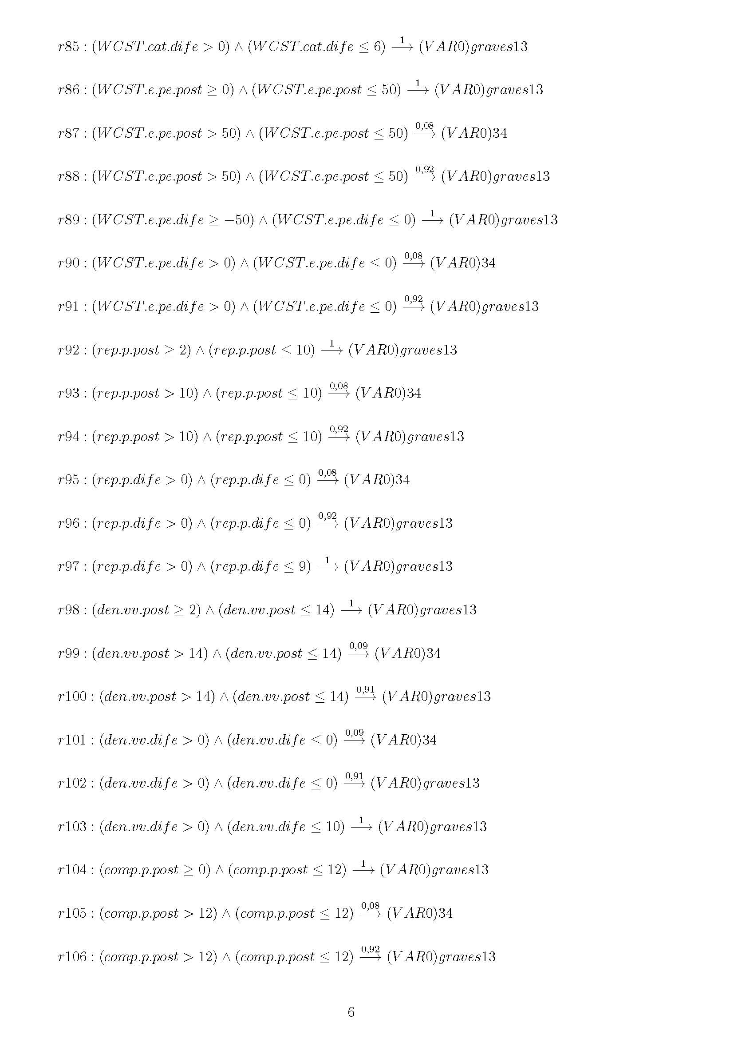

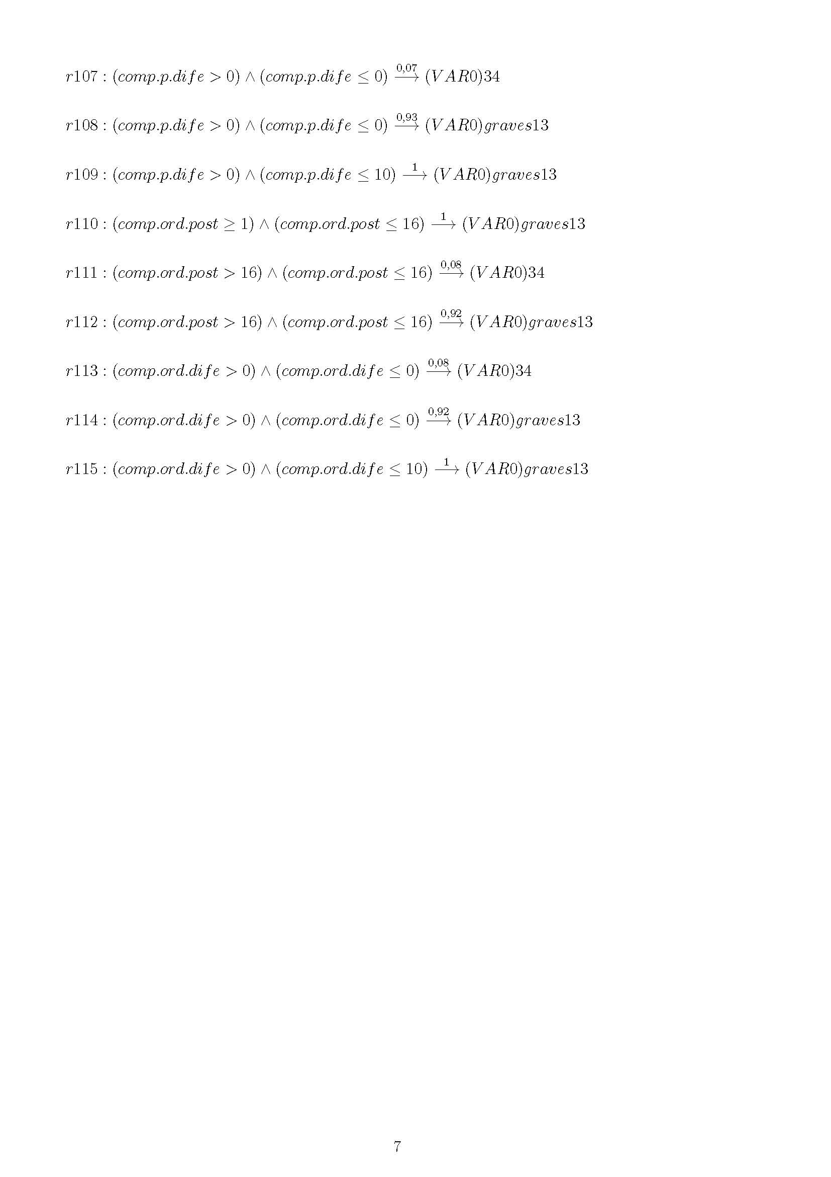

**Annex III: BC2**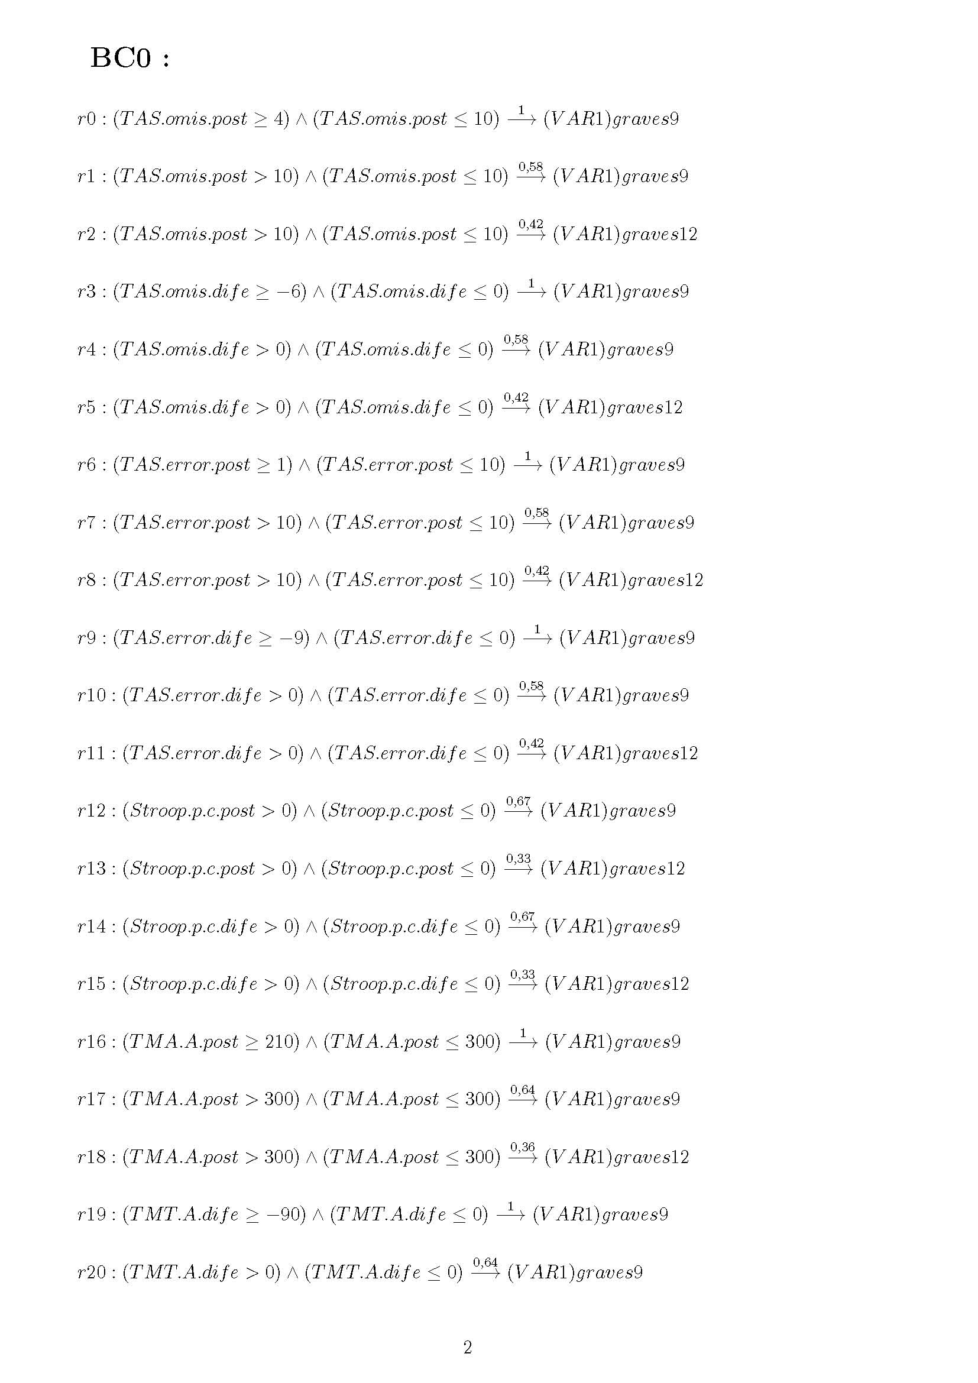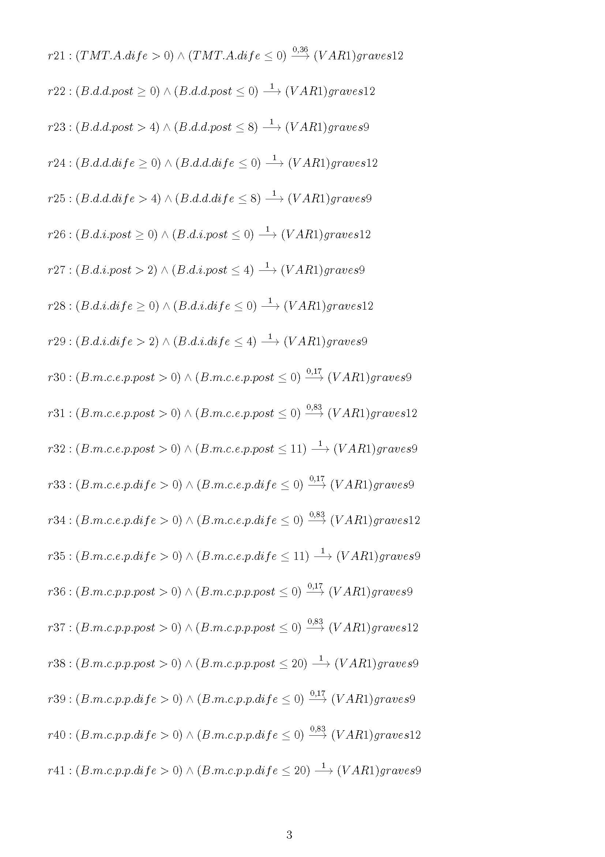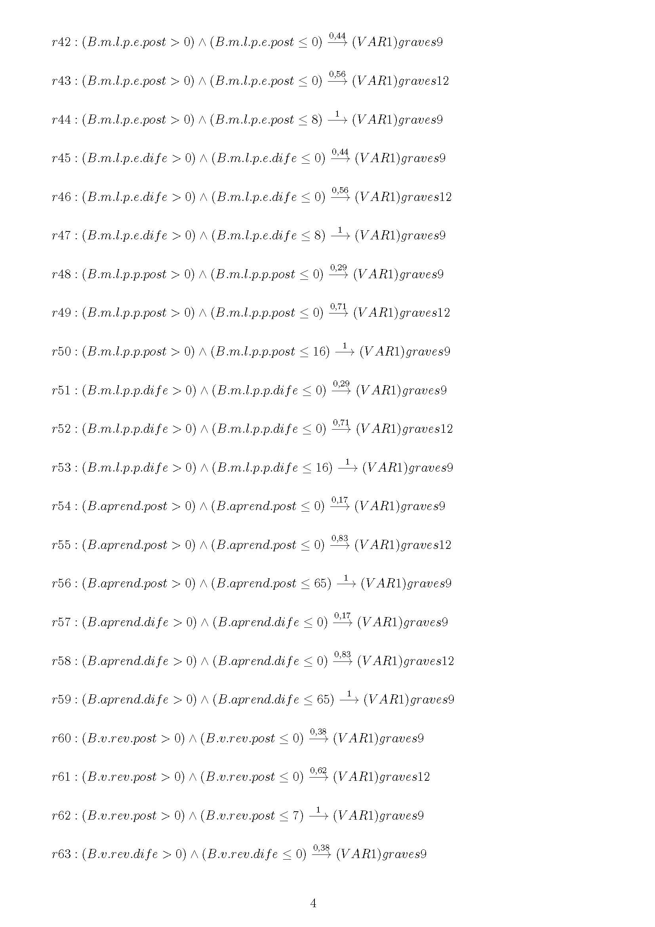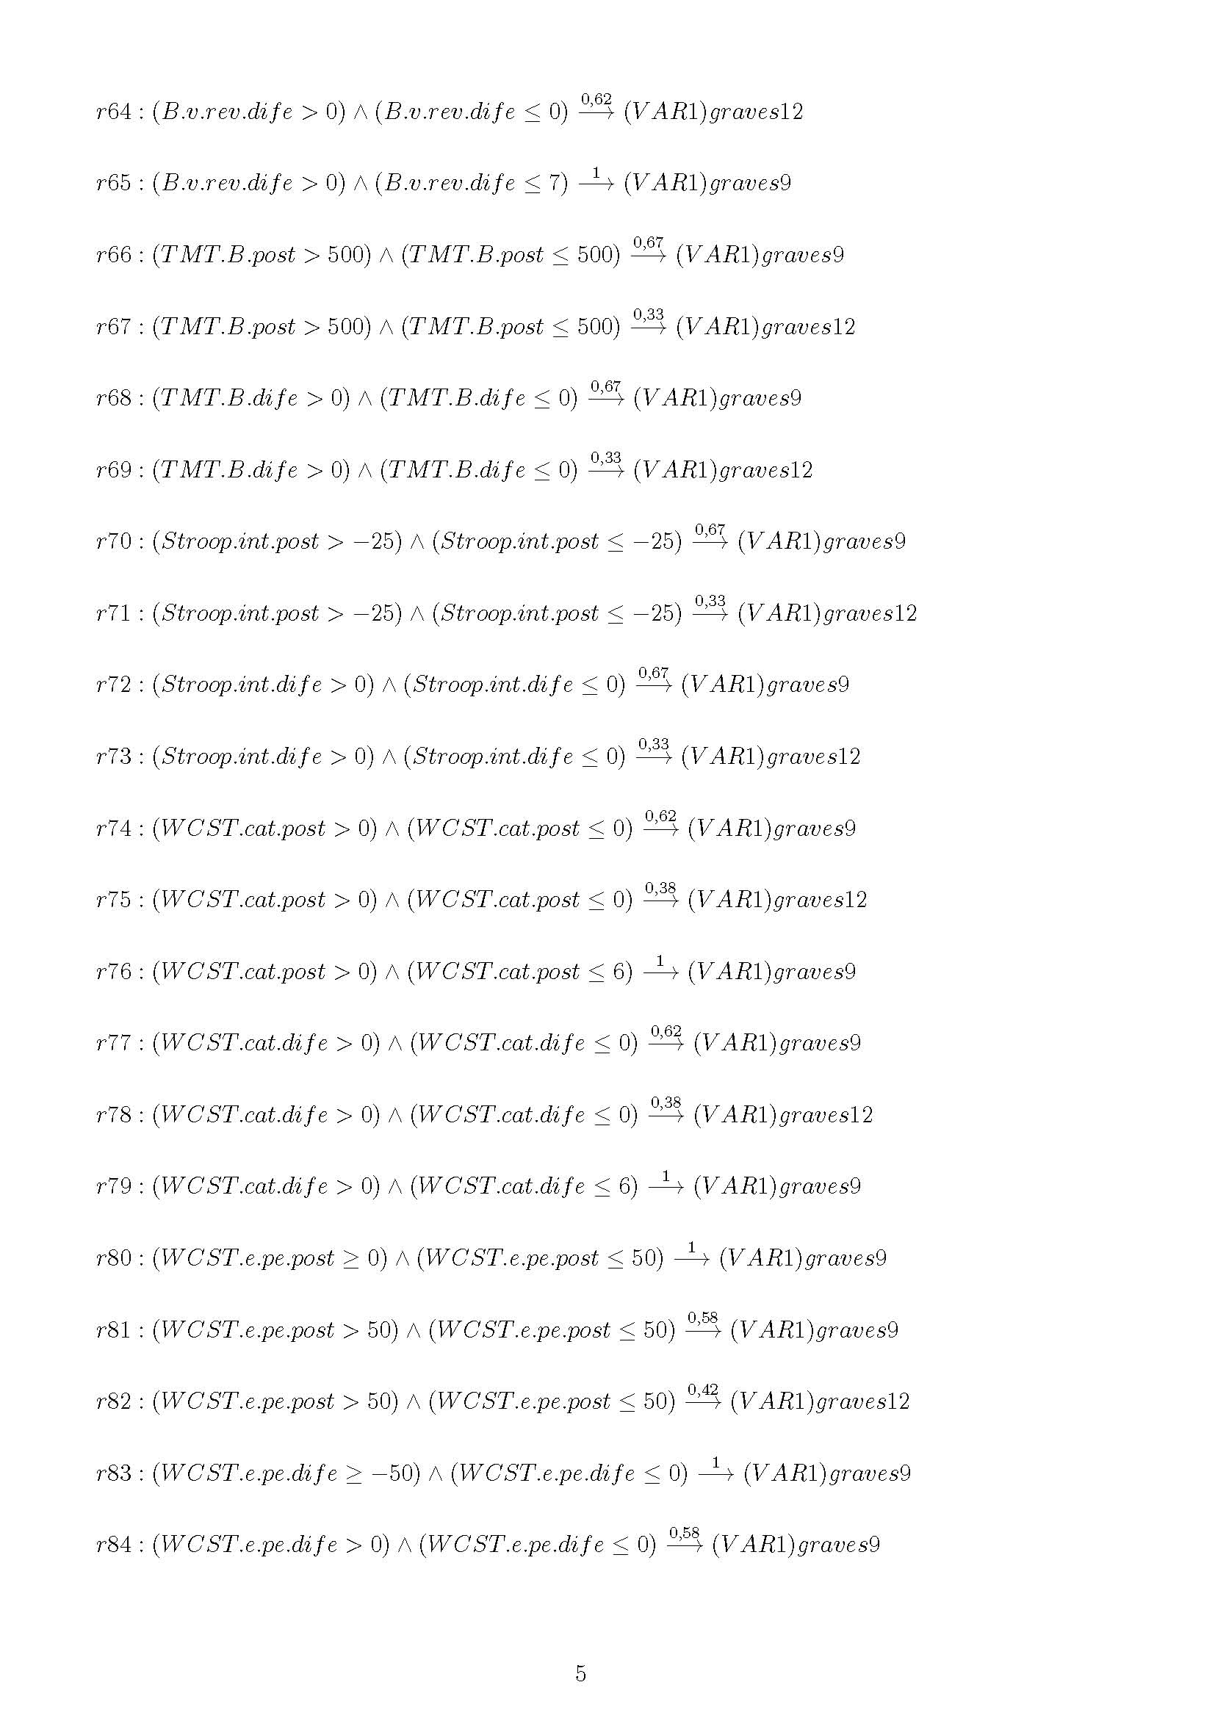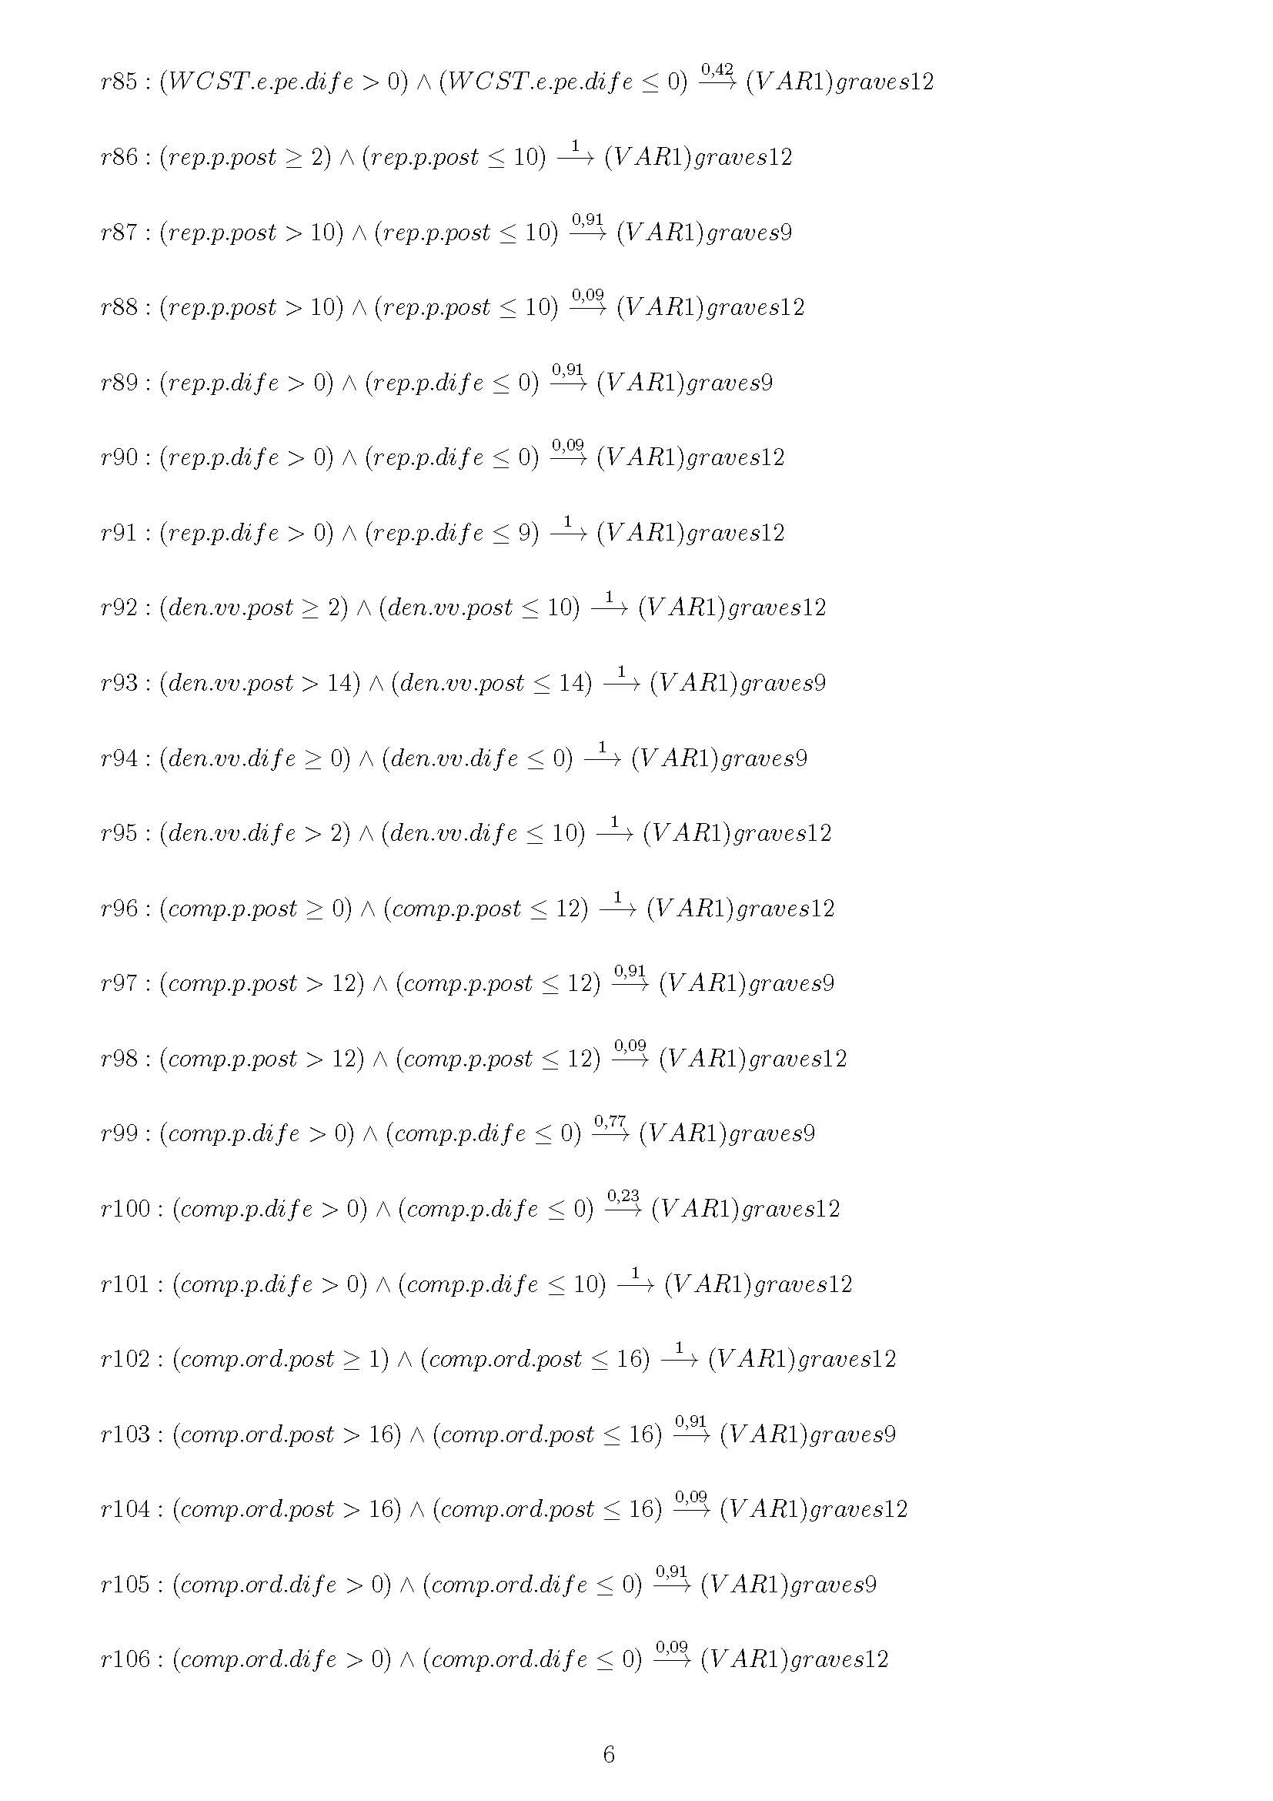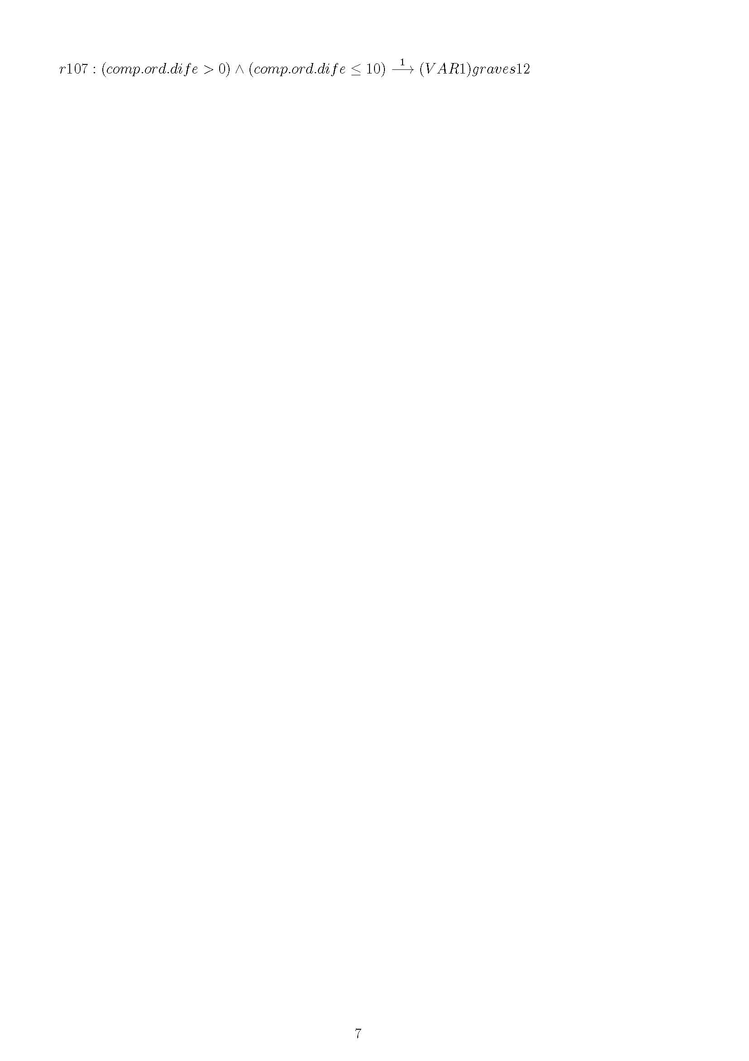

**Annex IV: BC3**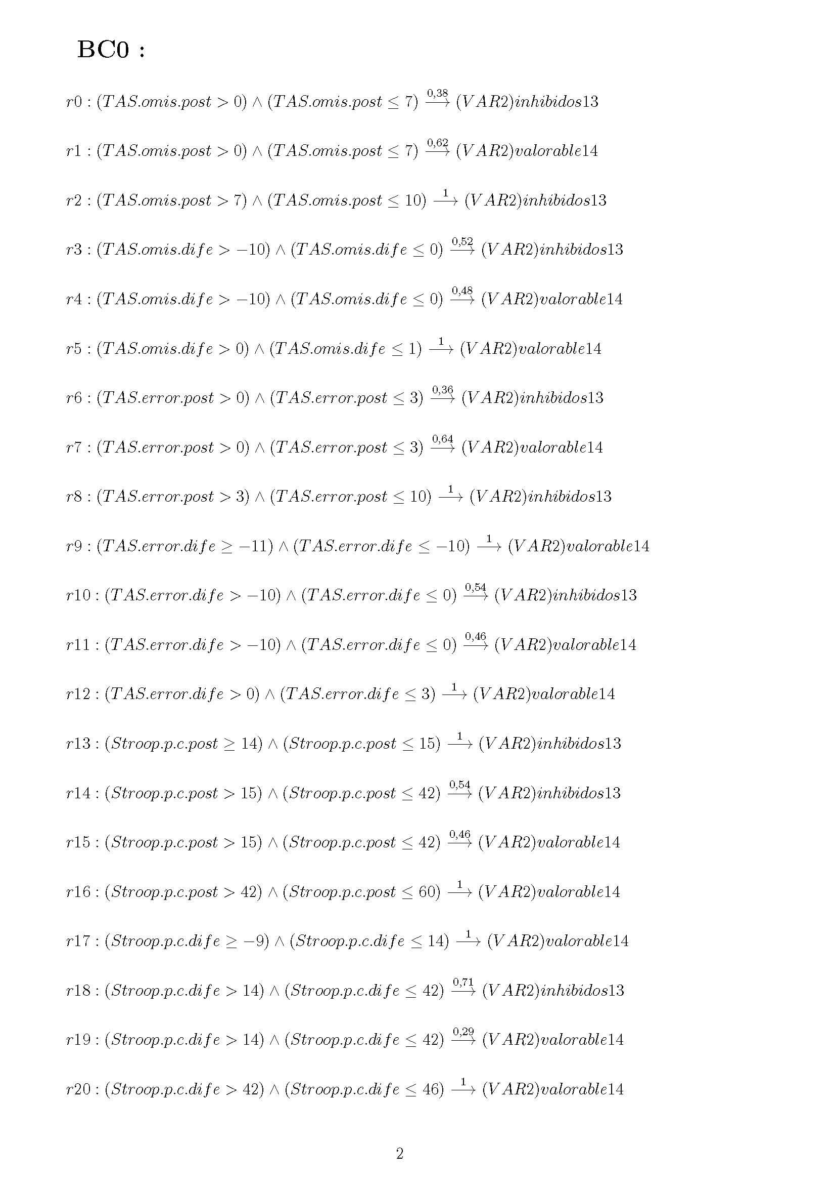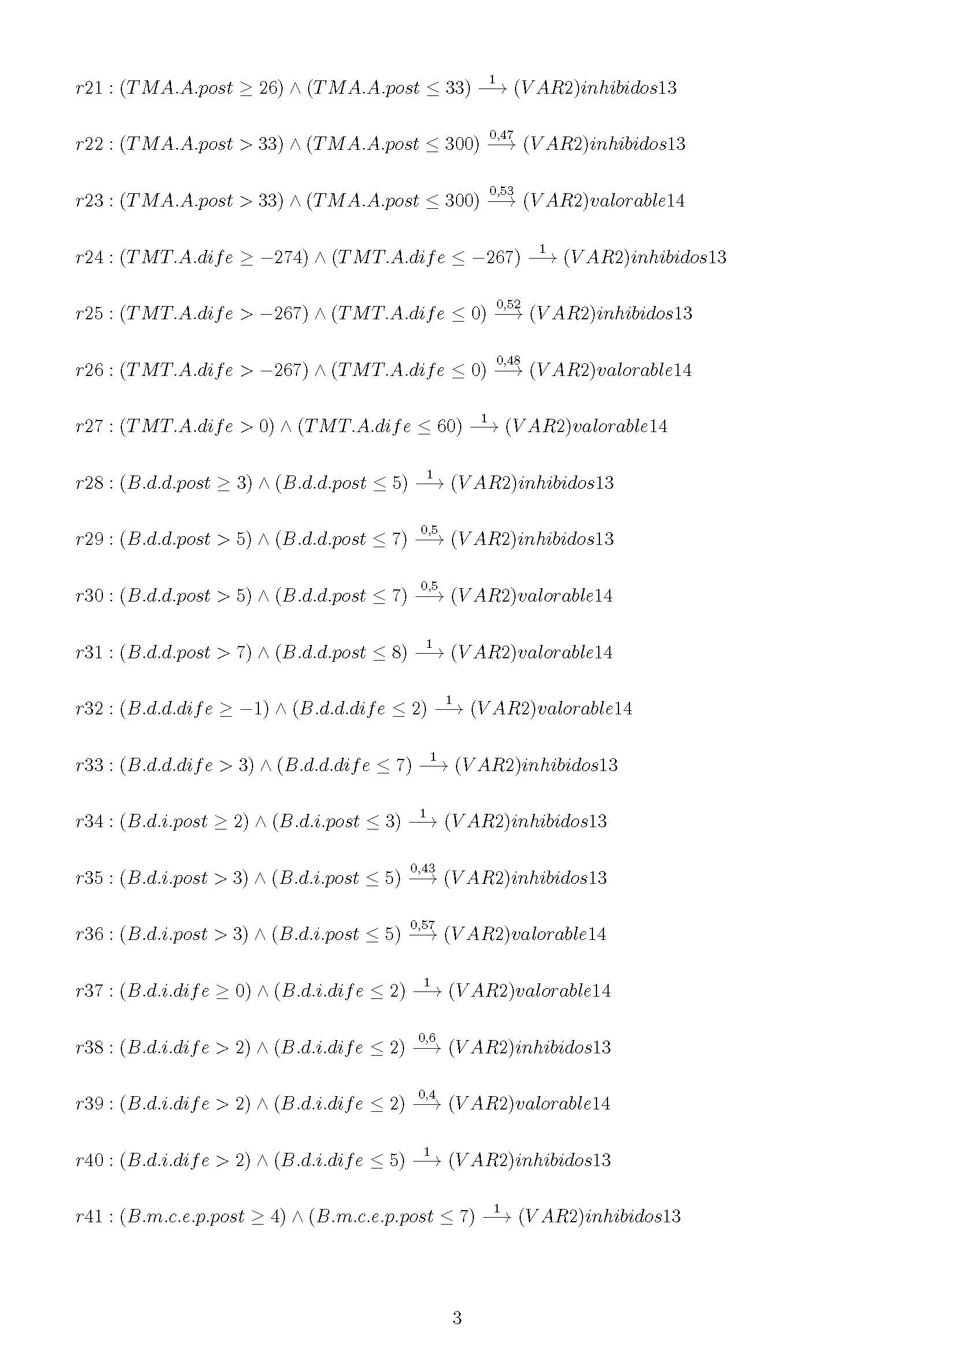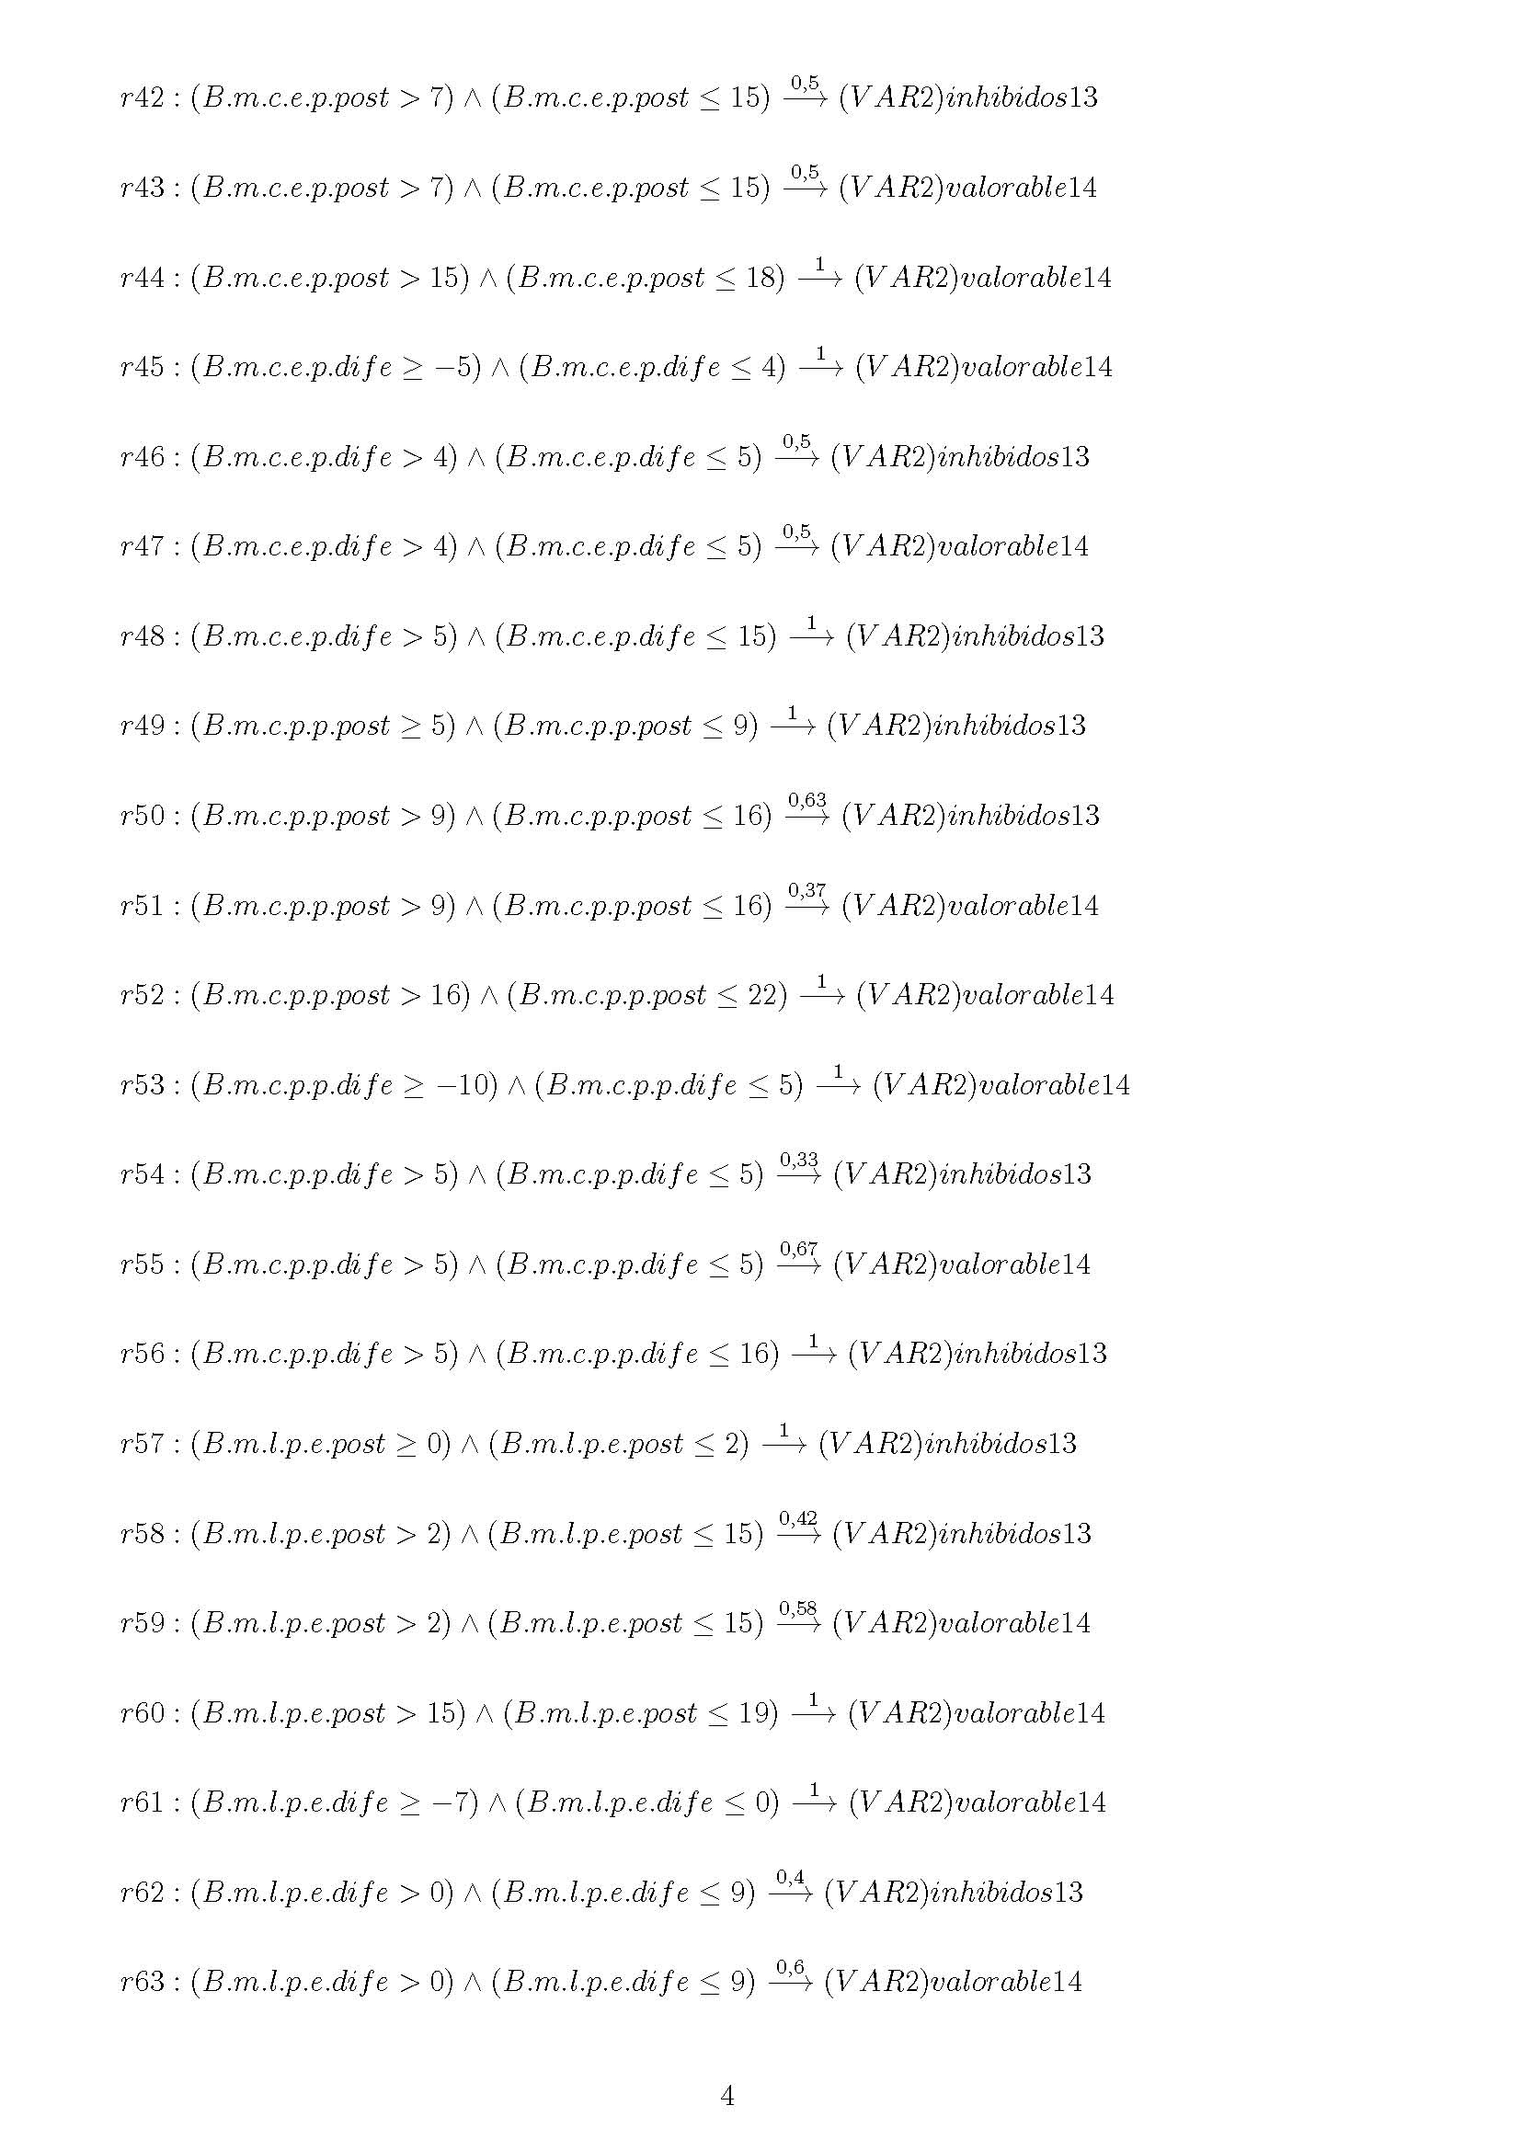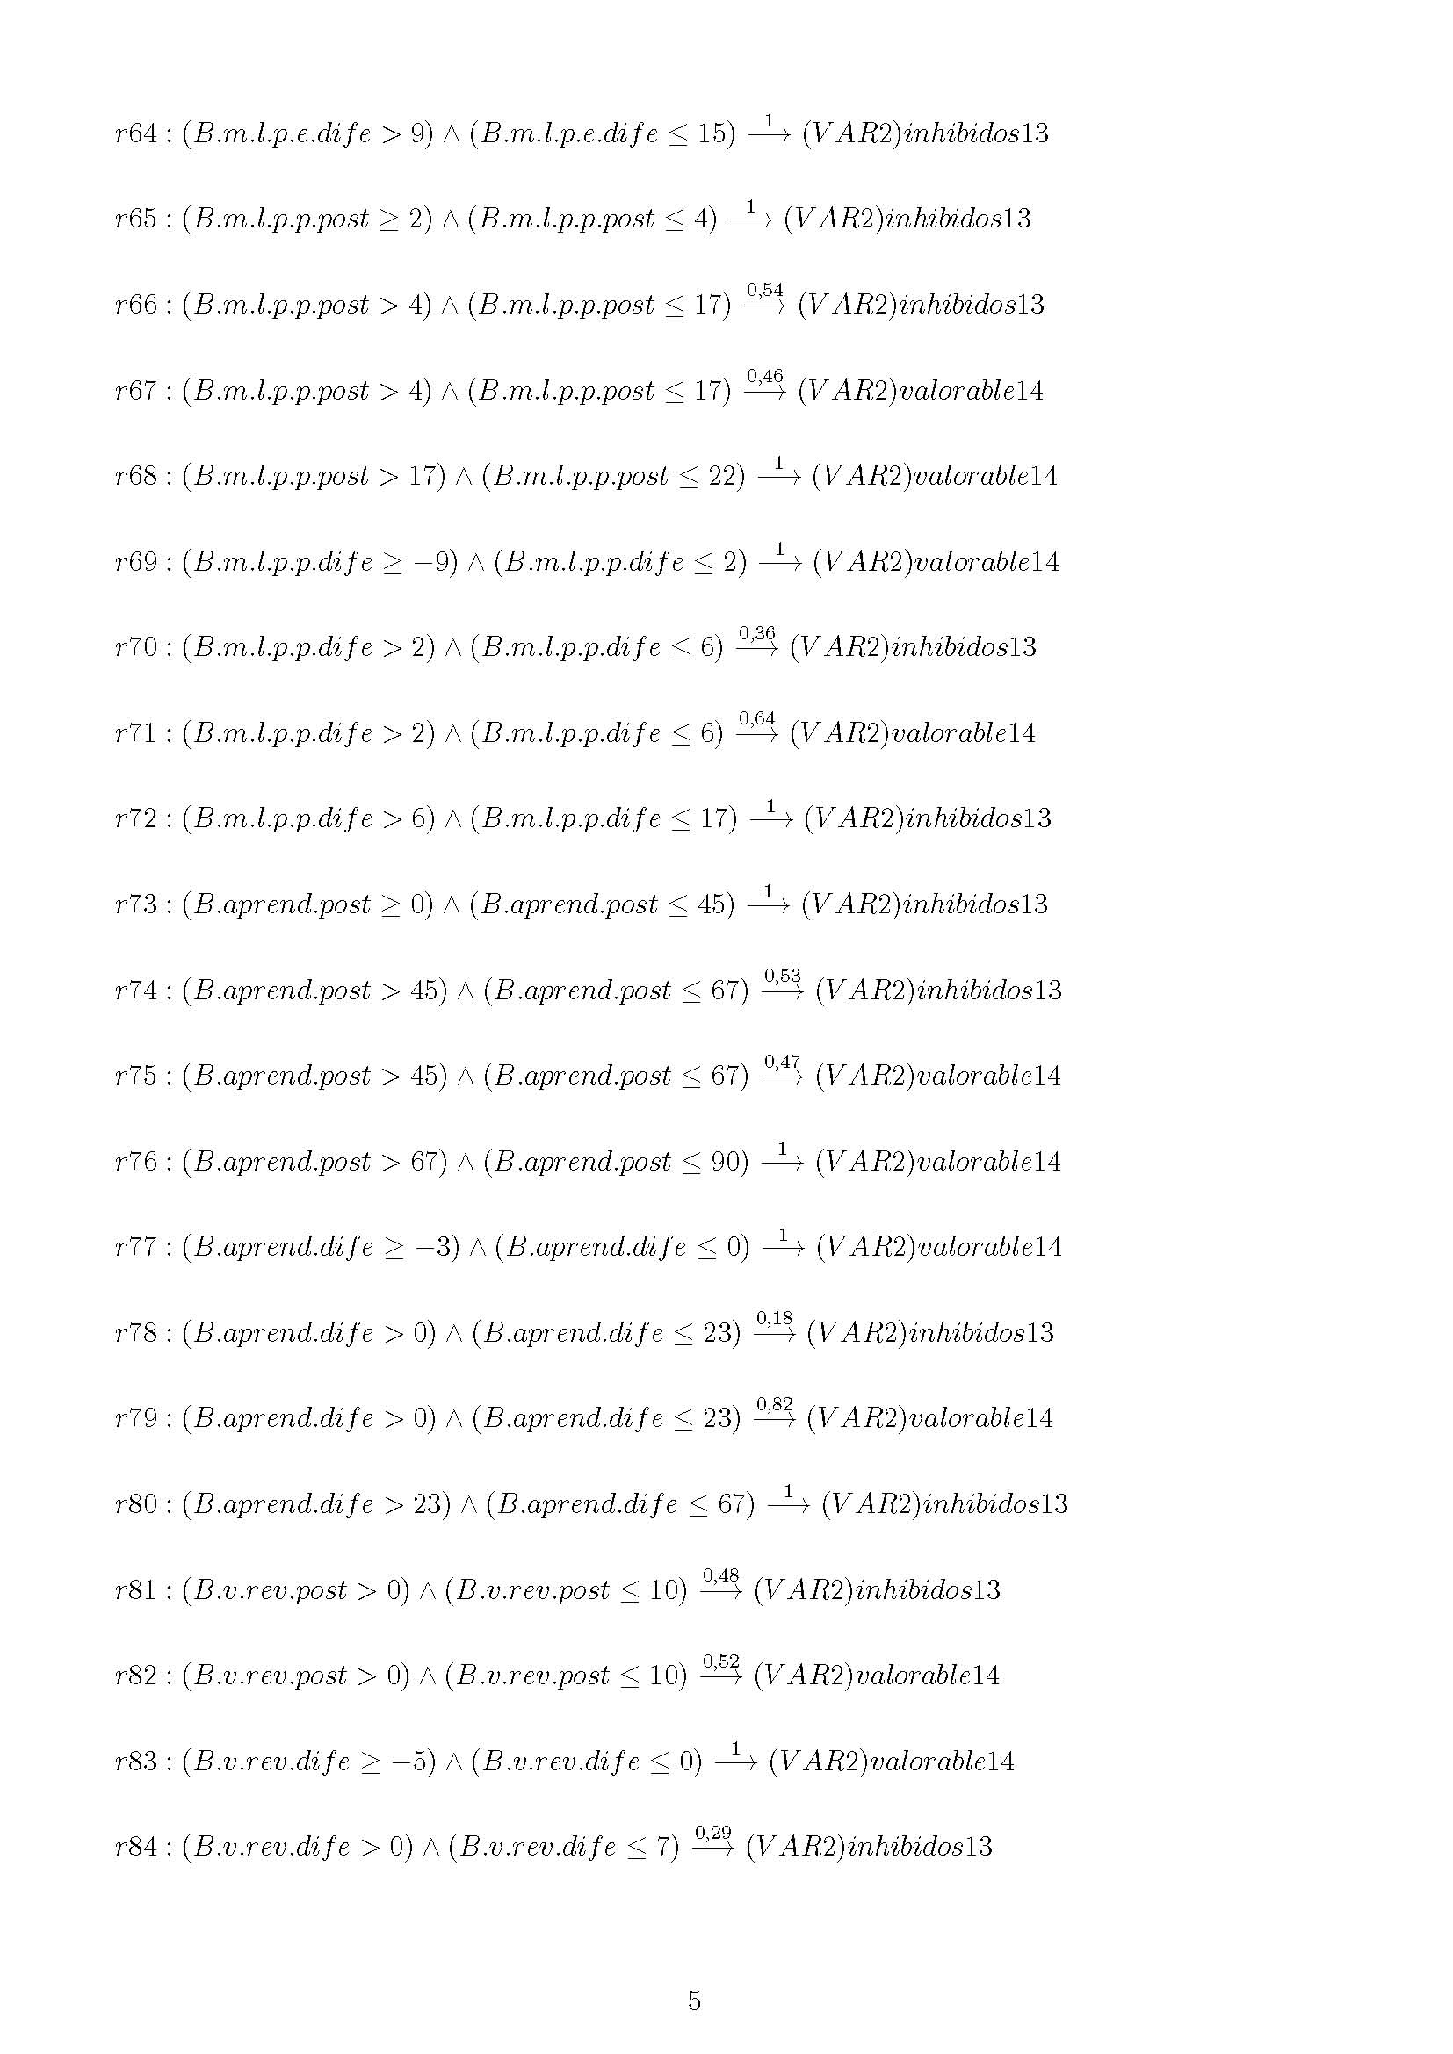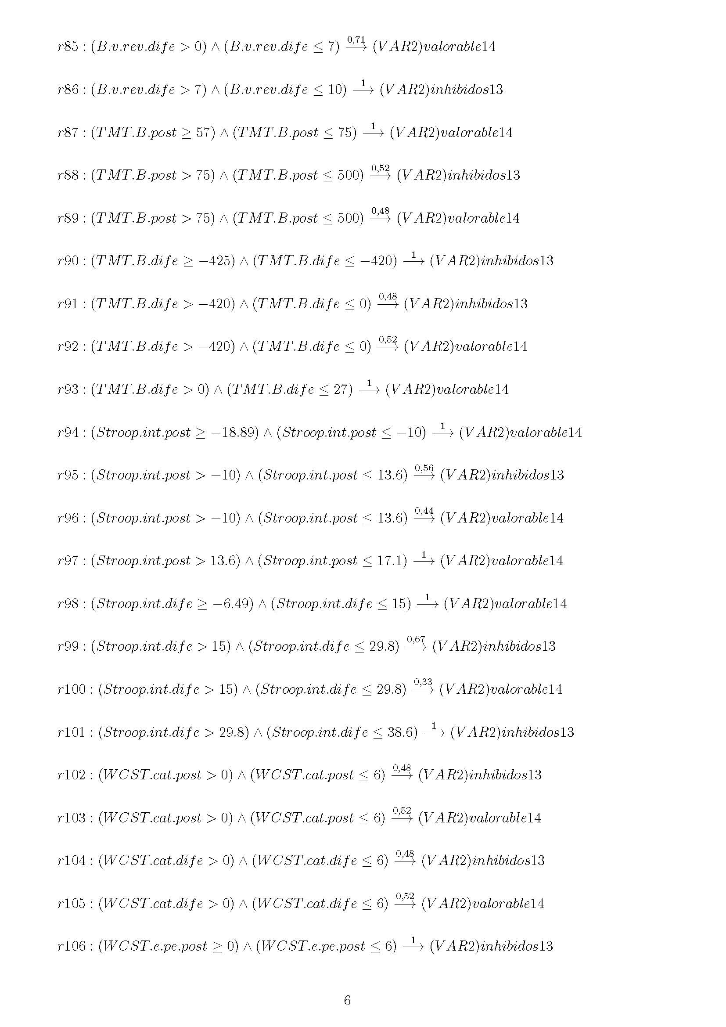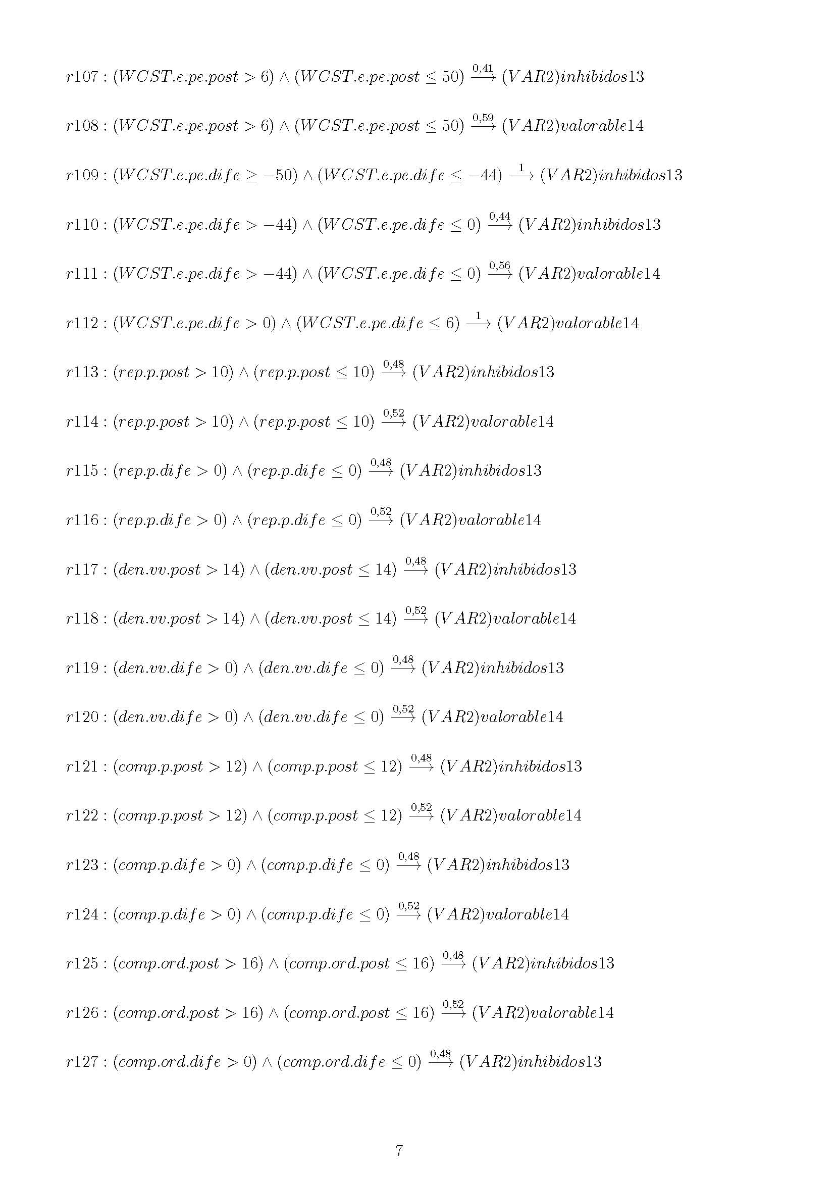

**Annex V: BC4**